1. grep ‘hello’ filename
this command is used to find the specified word in specified file

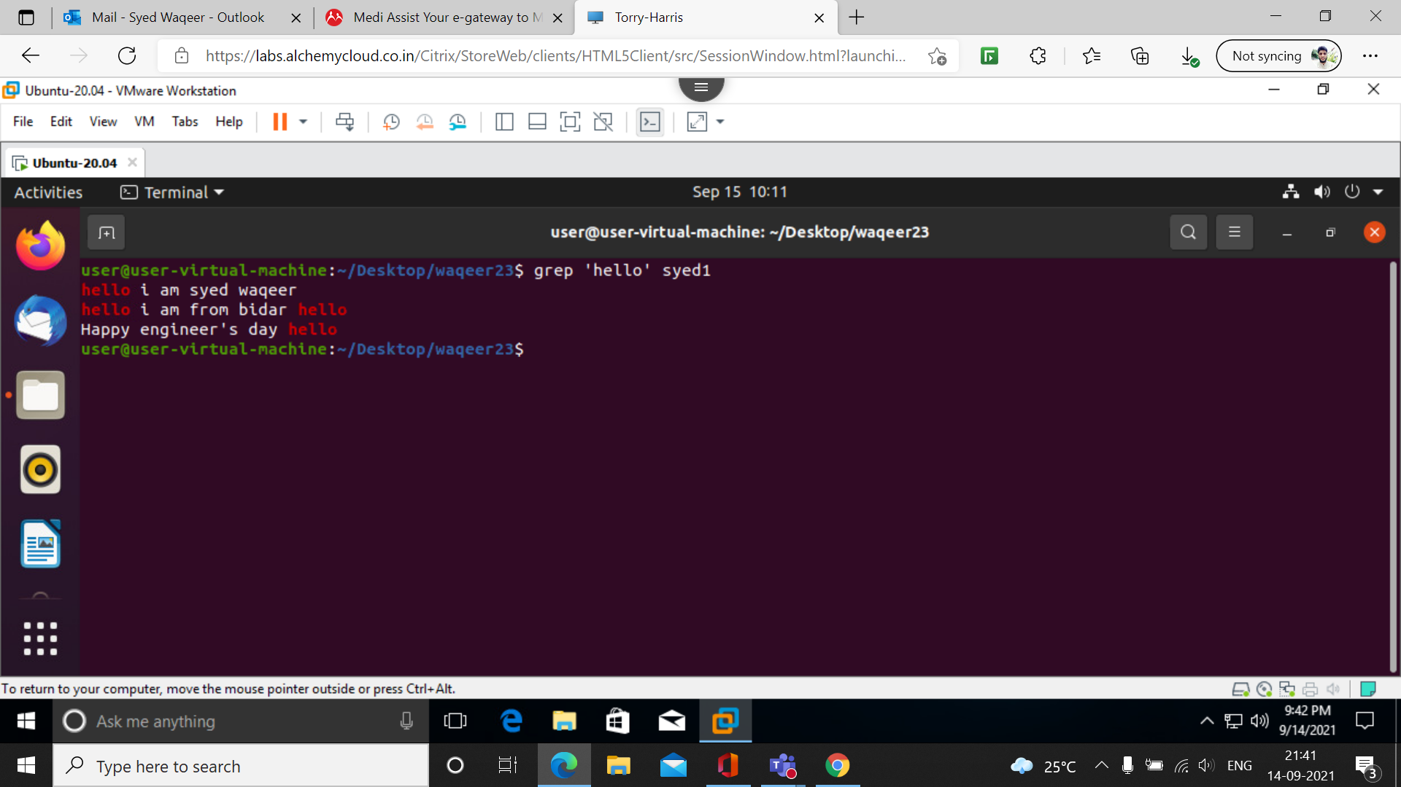
2. grep -i ‘hello’ filename
this command is used to find the specified word in specified file with ignoring case.

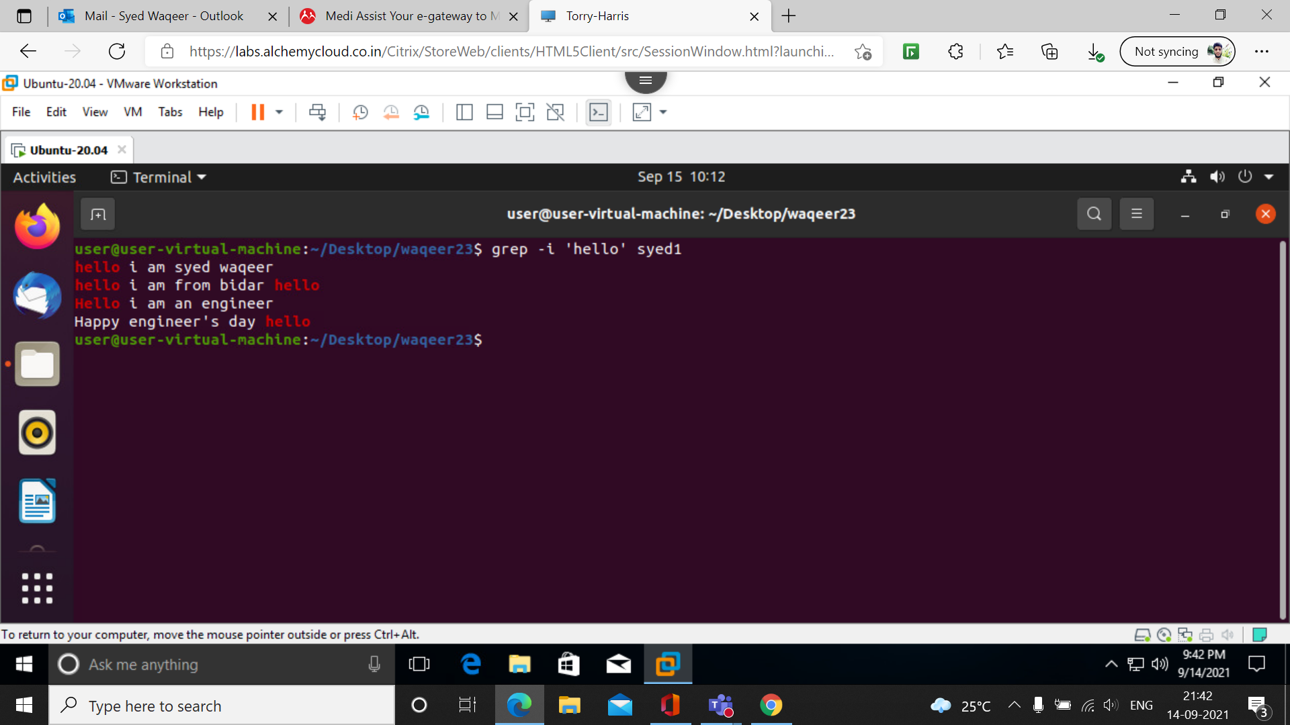

3. grep -c ‘hello’ filename
this command is used to display line number that containing the word

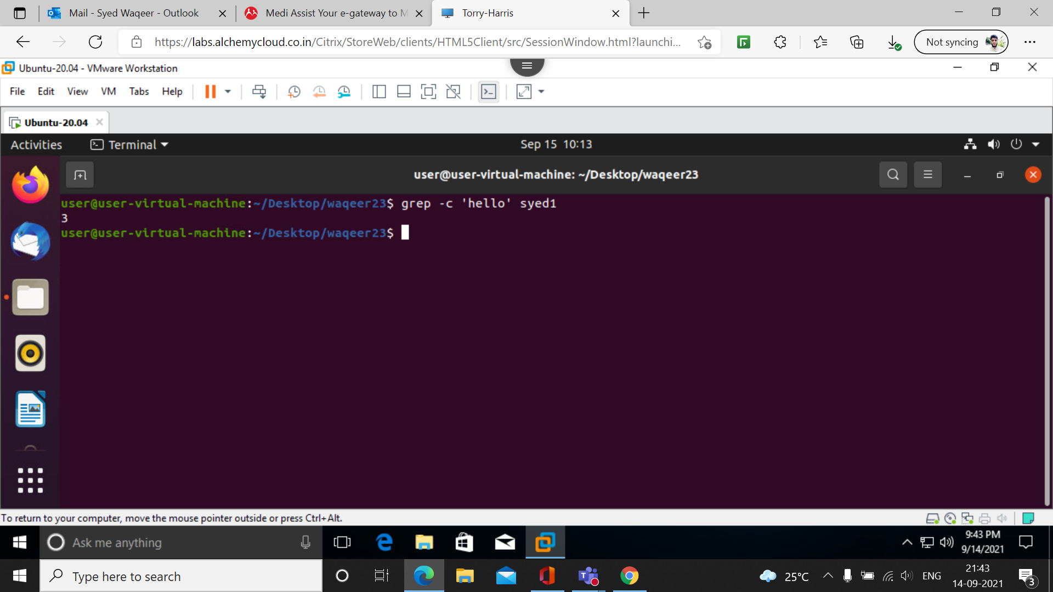
4. grep -l ‘hello’ filename
this command is to display the file name that containing the word.
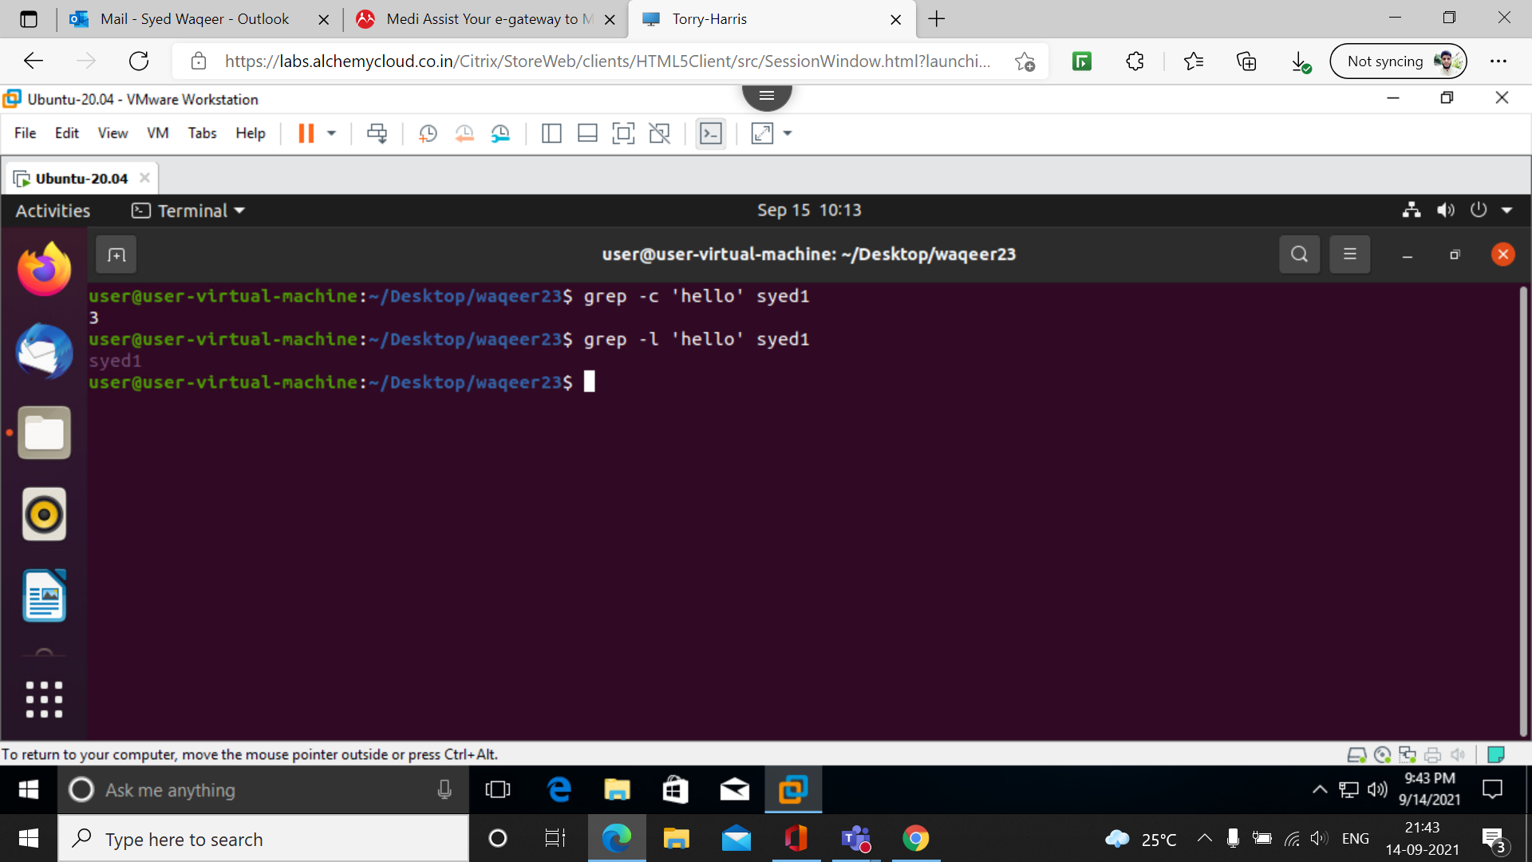

5. grep -l ‘hello’ filename filename
this command is to display the multiple file name that containing the word.

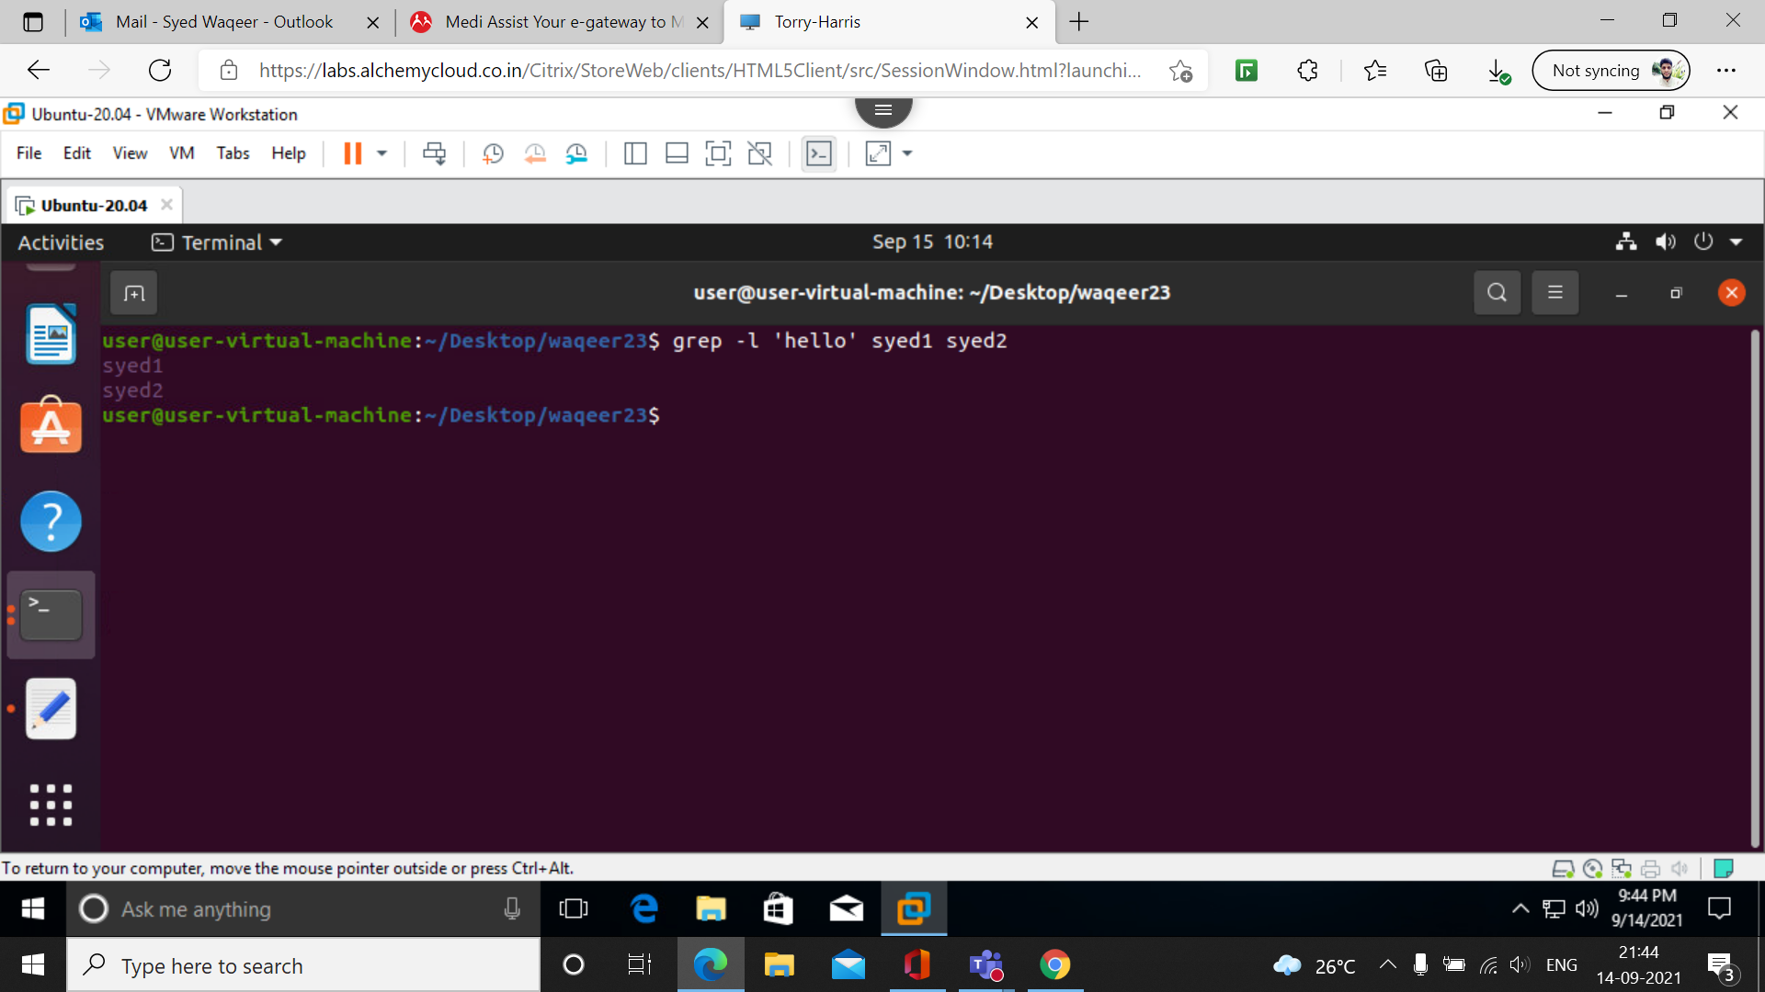
6. grep -w ‘hello’ filename
this command is to find the exact word in the given file
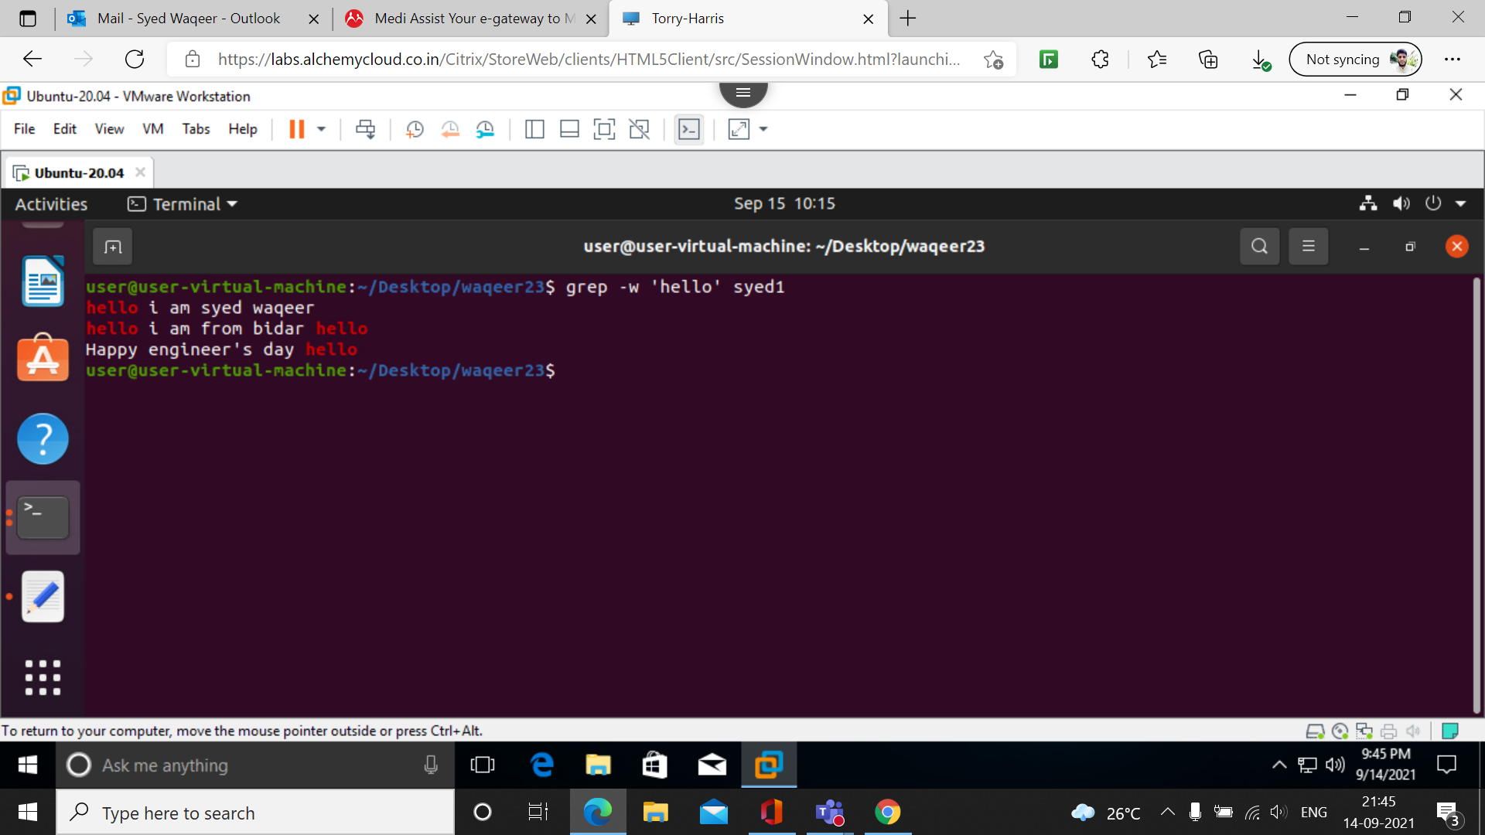

7. grep -o ‘hello’ filename
this command is to find full string matching to the given word in given file.

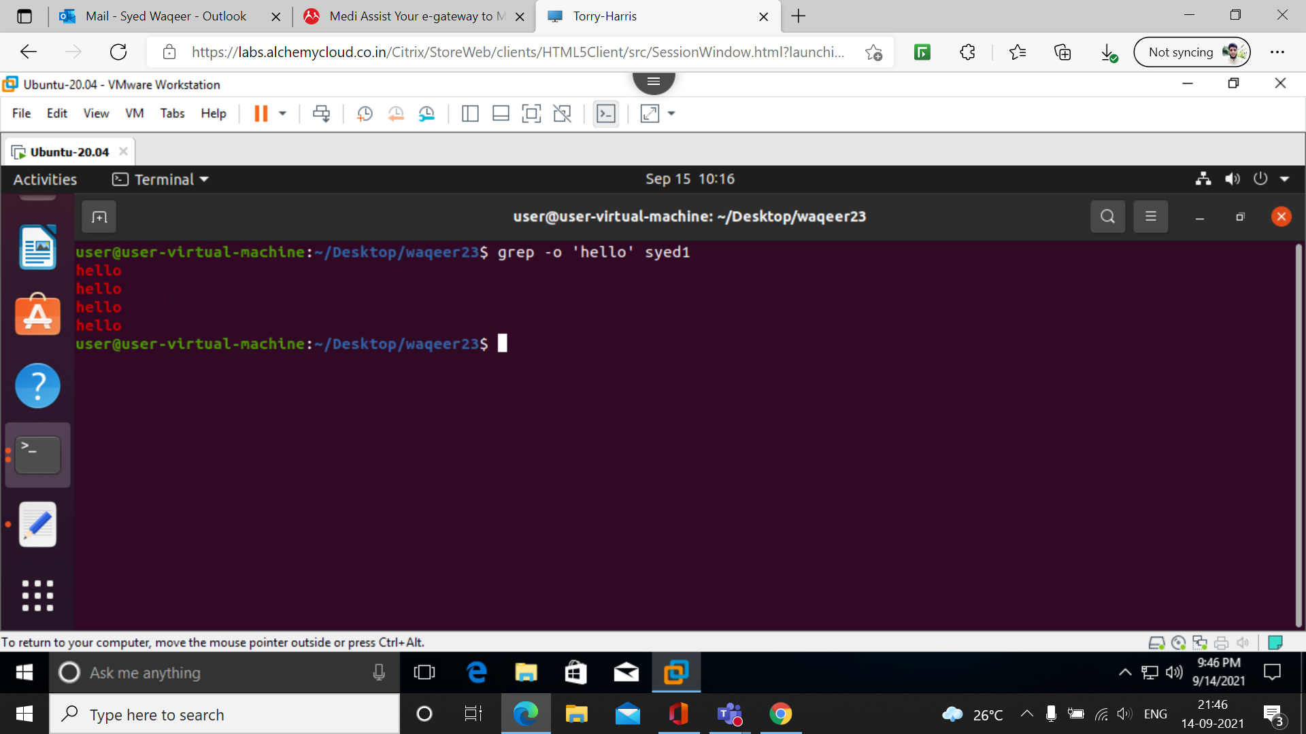
8. grep -oiw ‘hello’ filename

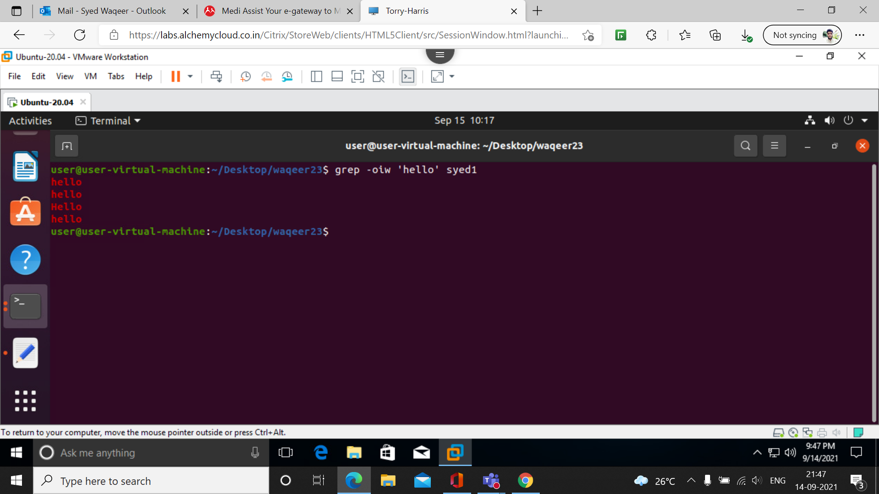

9. grep -n ‘hello’ filename
this command is used to display the line number that contain the given word

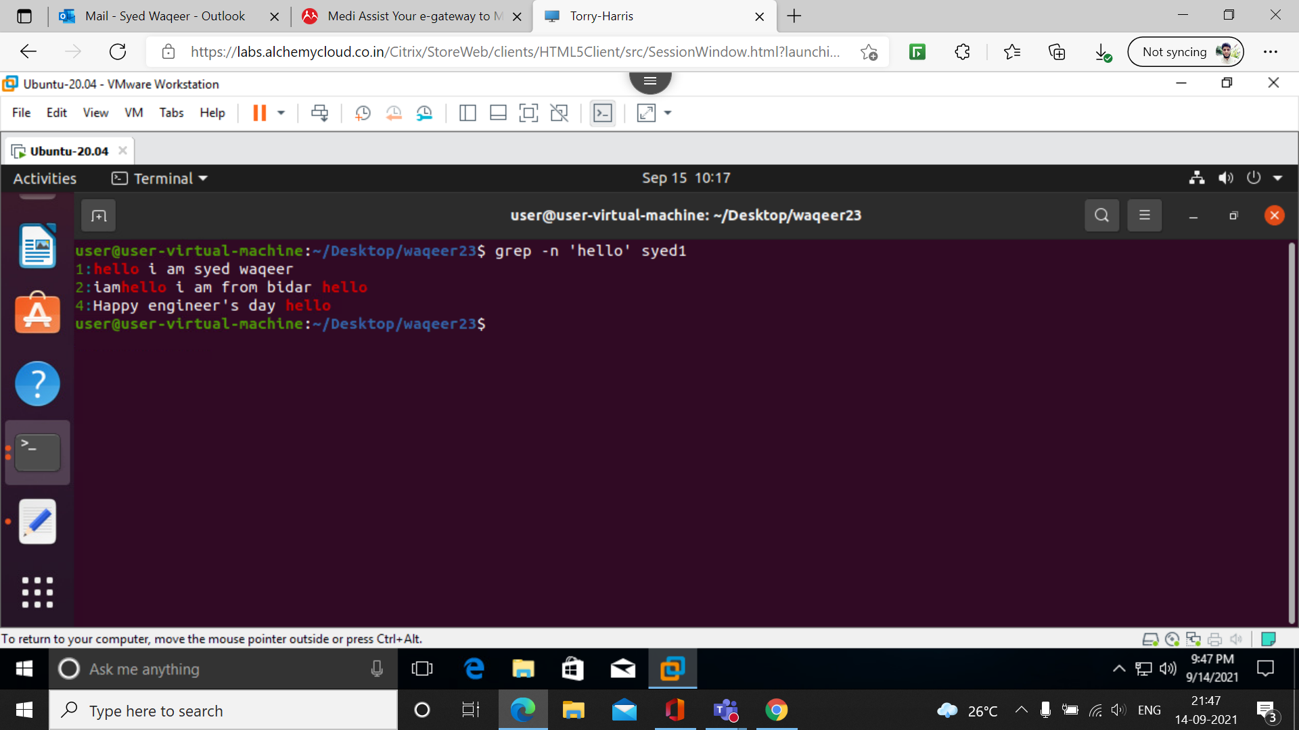
10. grep -niow ‘hello’ filename

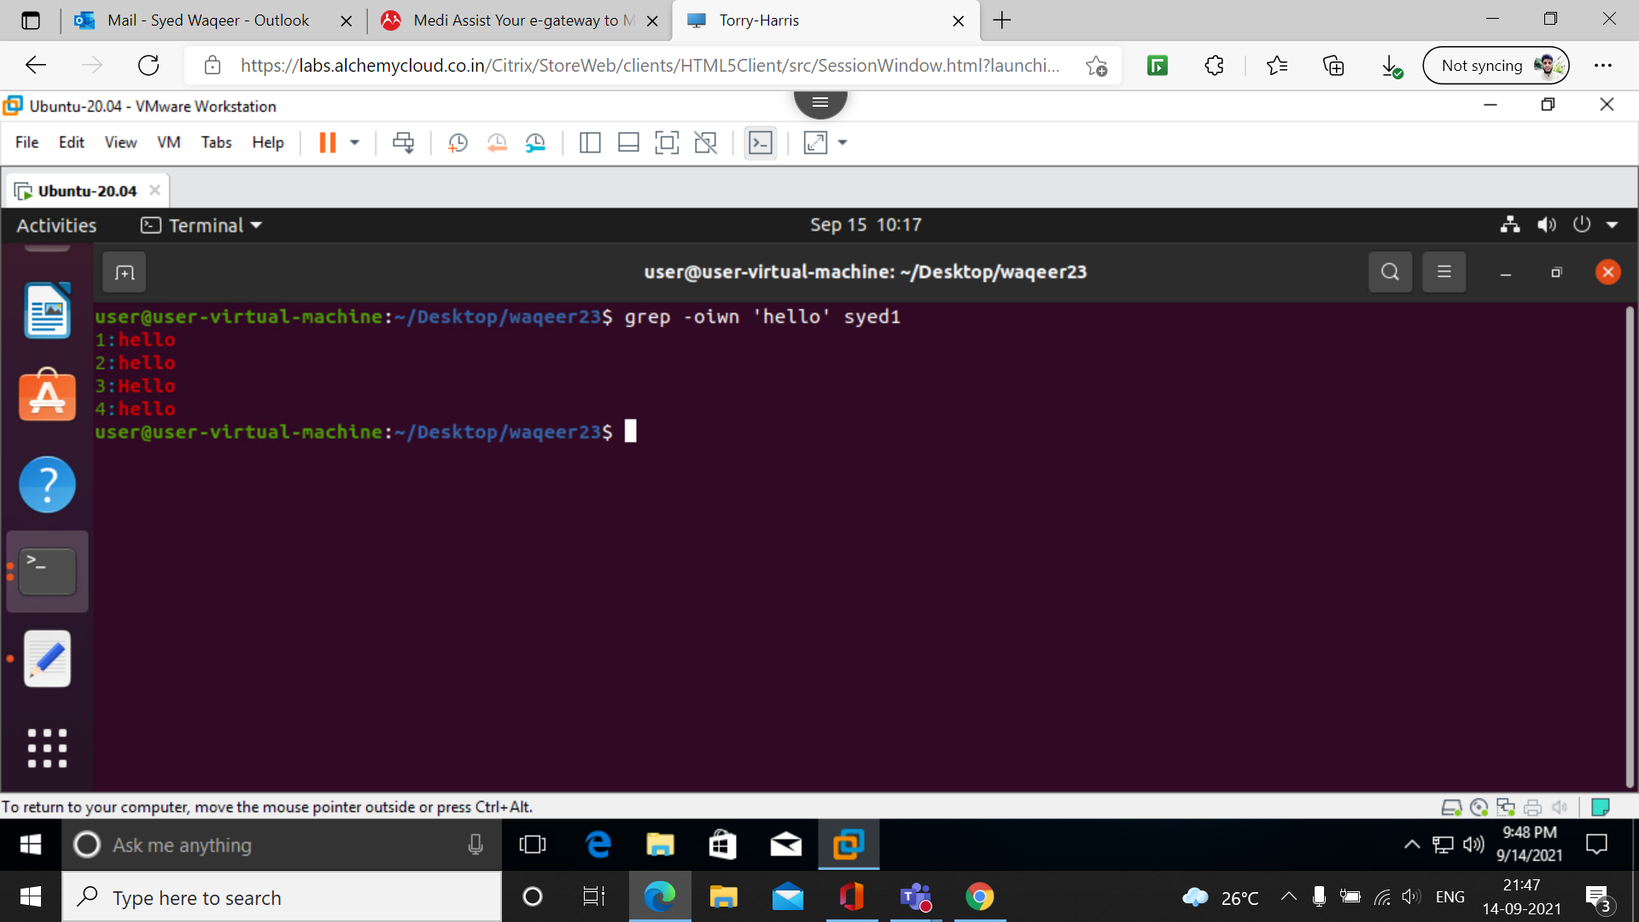

11. grep -v ‘hello’ filename

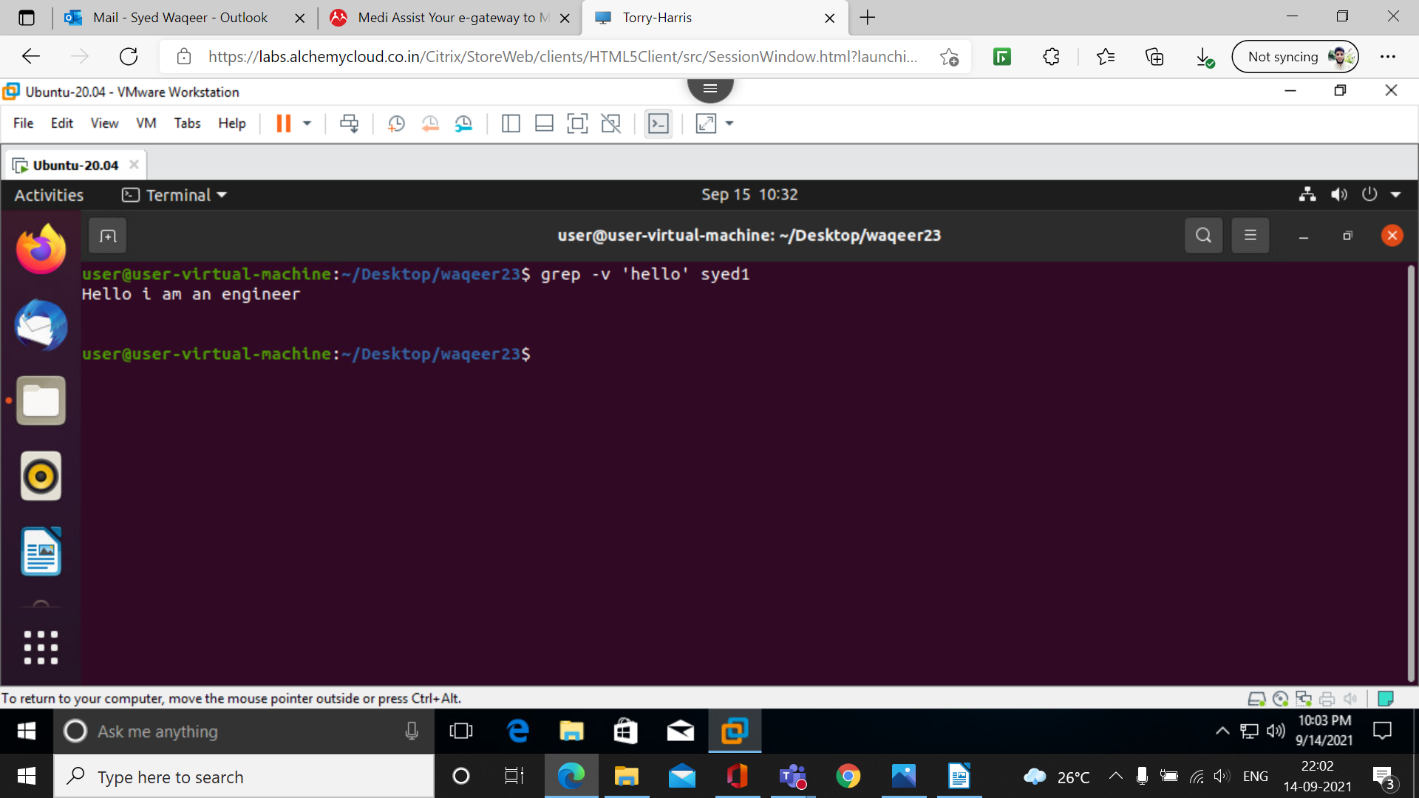

12.grep -vin ‘hello’ filename

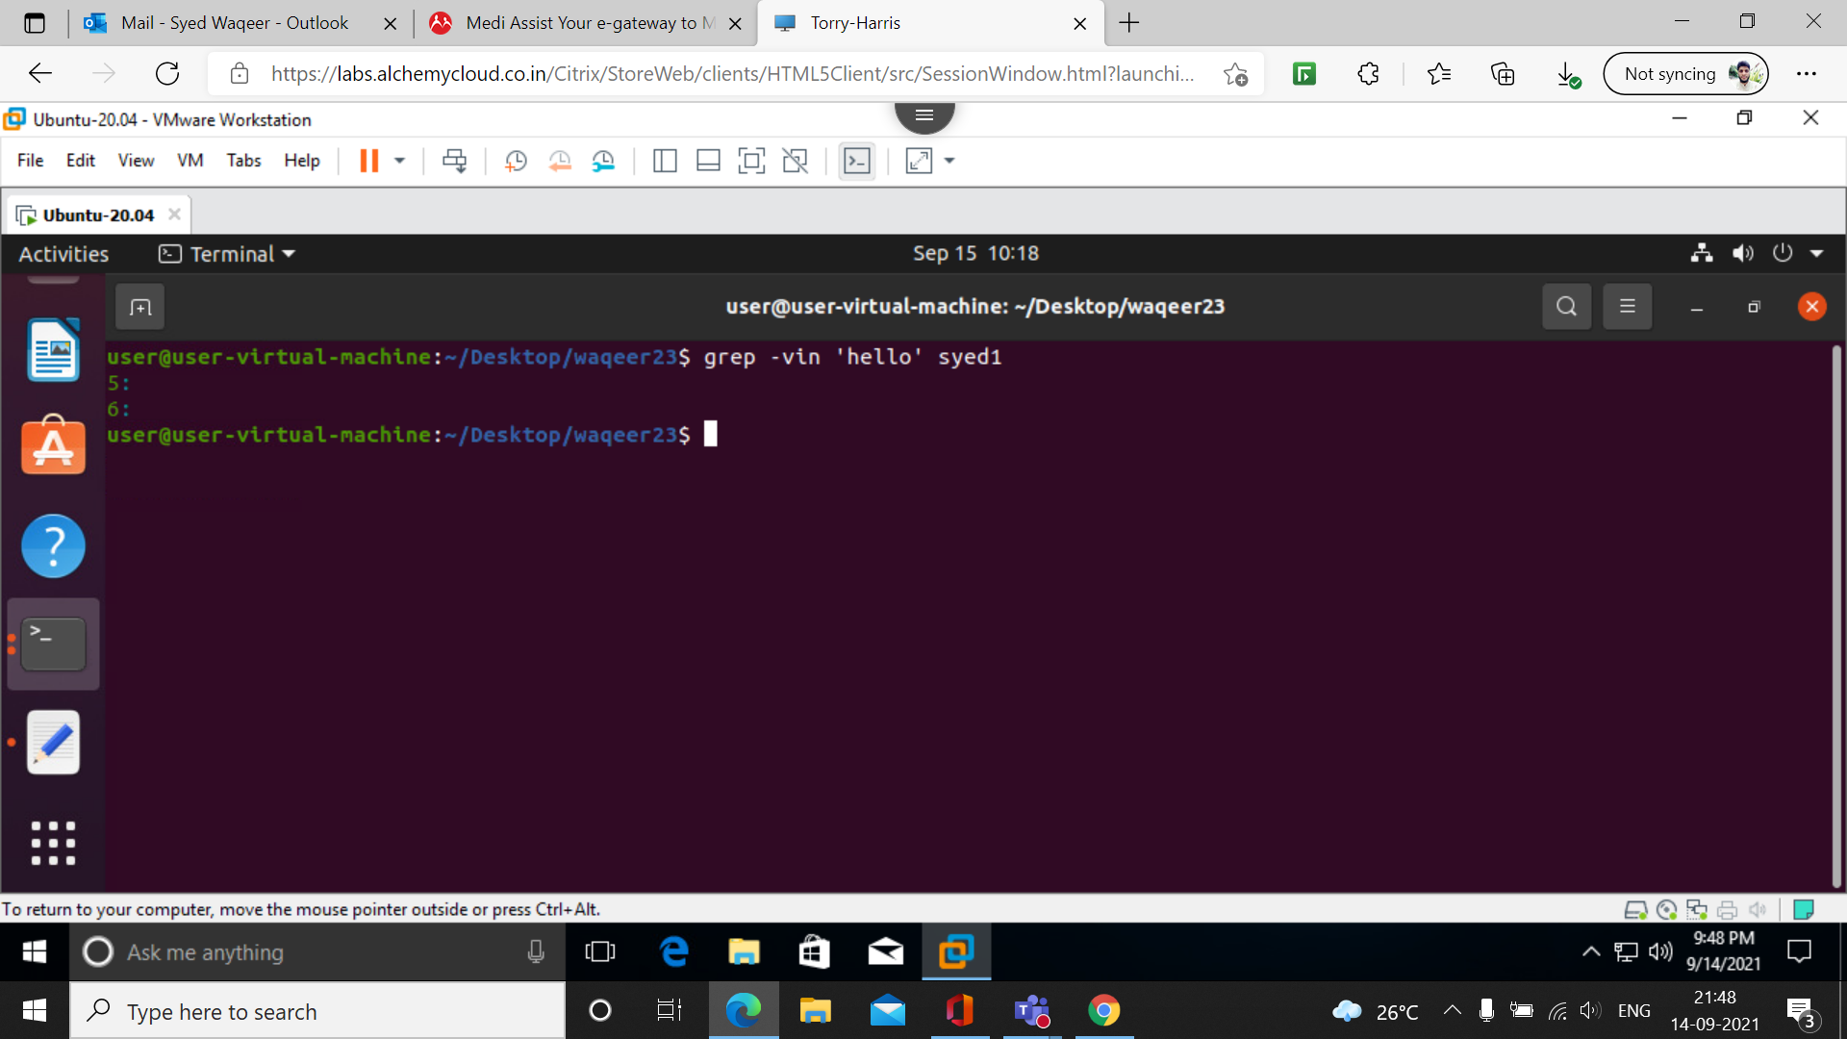

13. grep ‘^hello’ filename
this command is used to find the line starting with the specified word in the command.

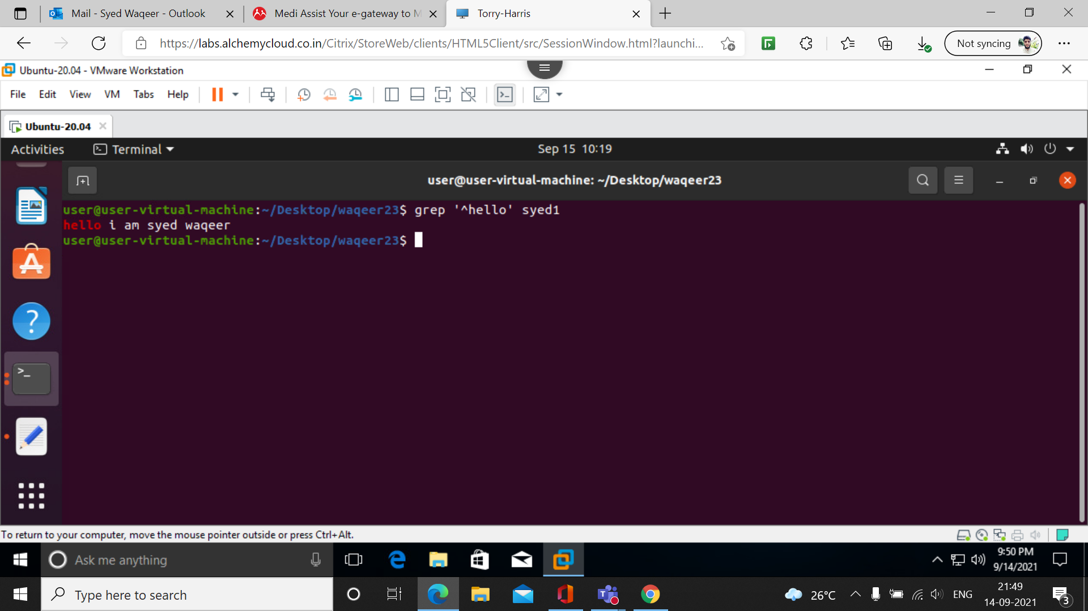
14. grep ‘hello$’ filename
this command is used to find the line ending with the specified word in the command.

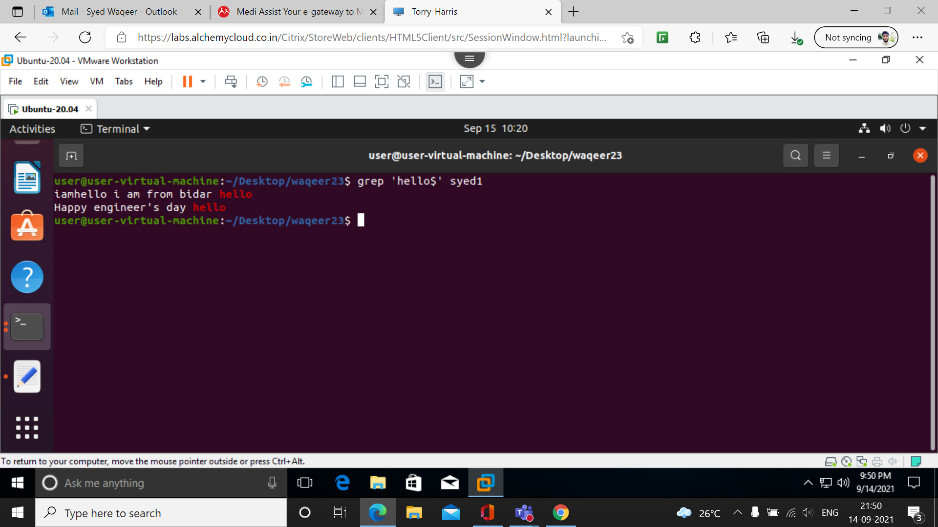

15.[ ]:
Matches any one of a set characters

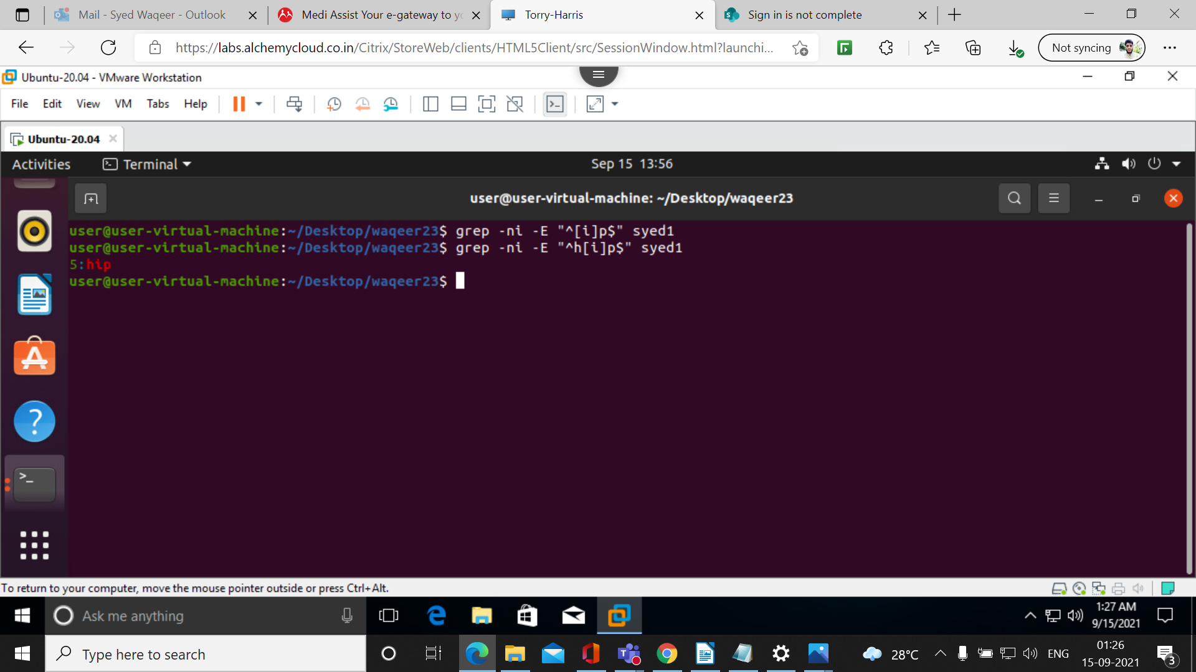
16.[ ] with hyphen:
Matches any one of a range characters

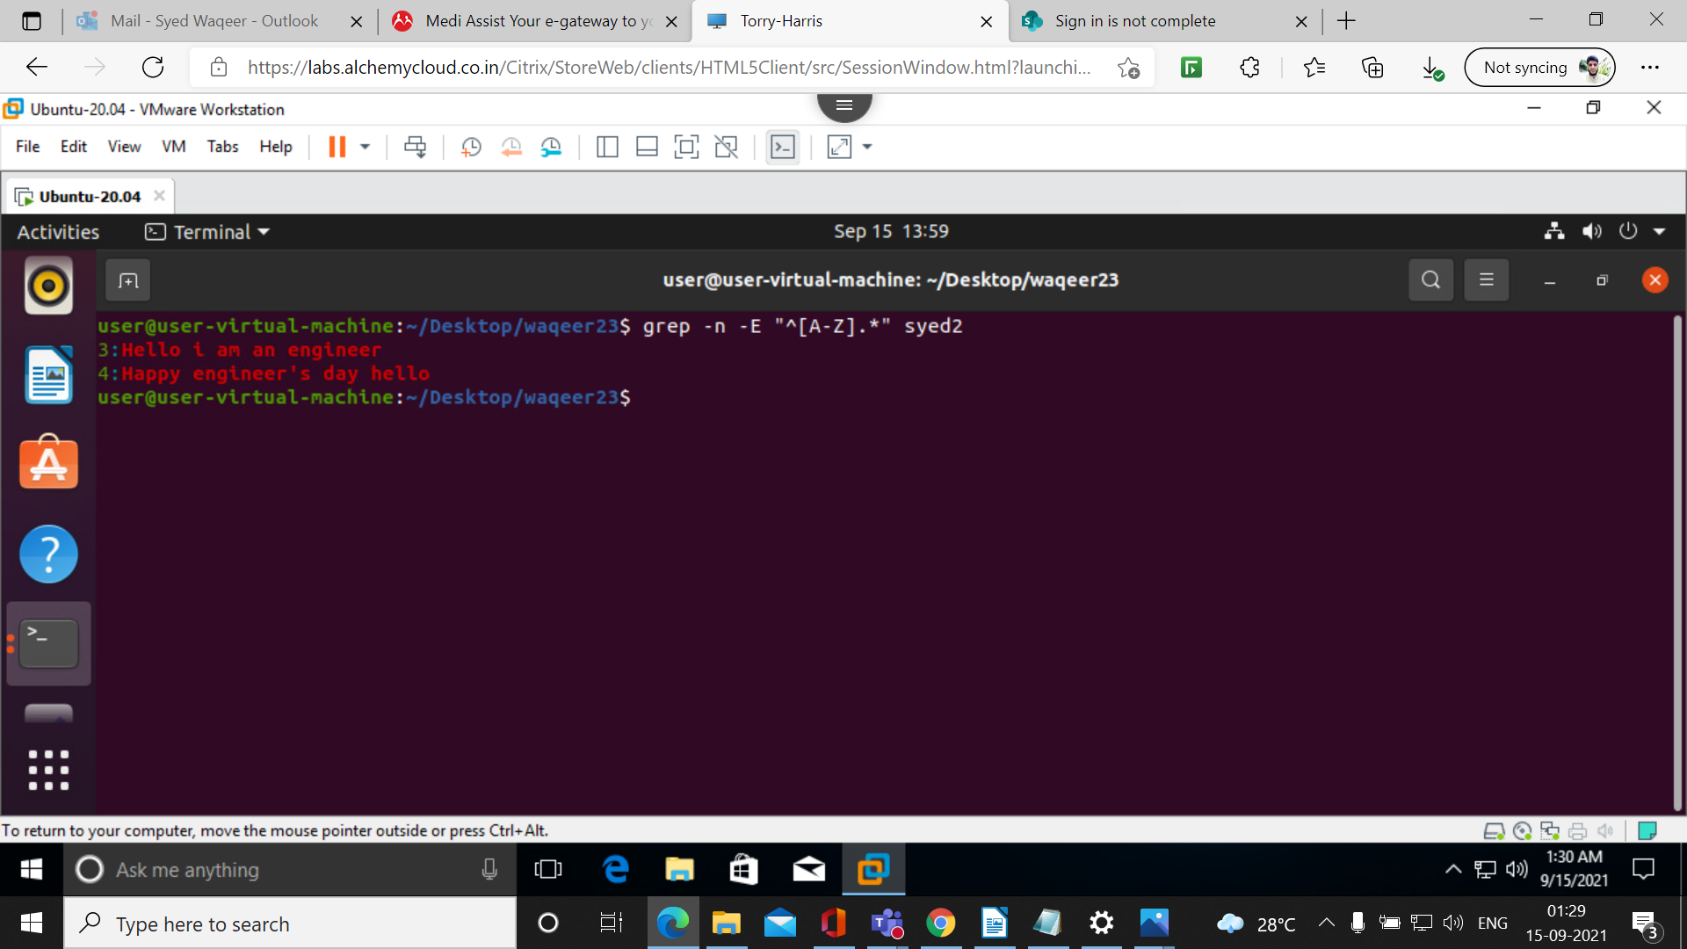

17. ^ with [ ] :
The pattern must not contain any character in the set specified

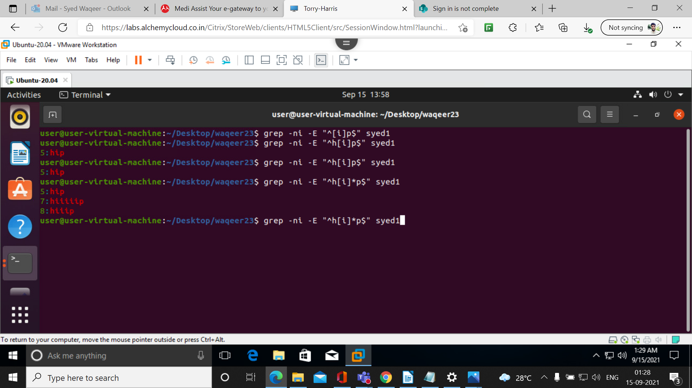
18 . (dot):
Matches any one character

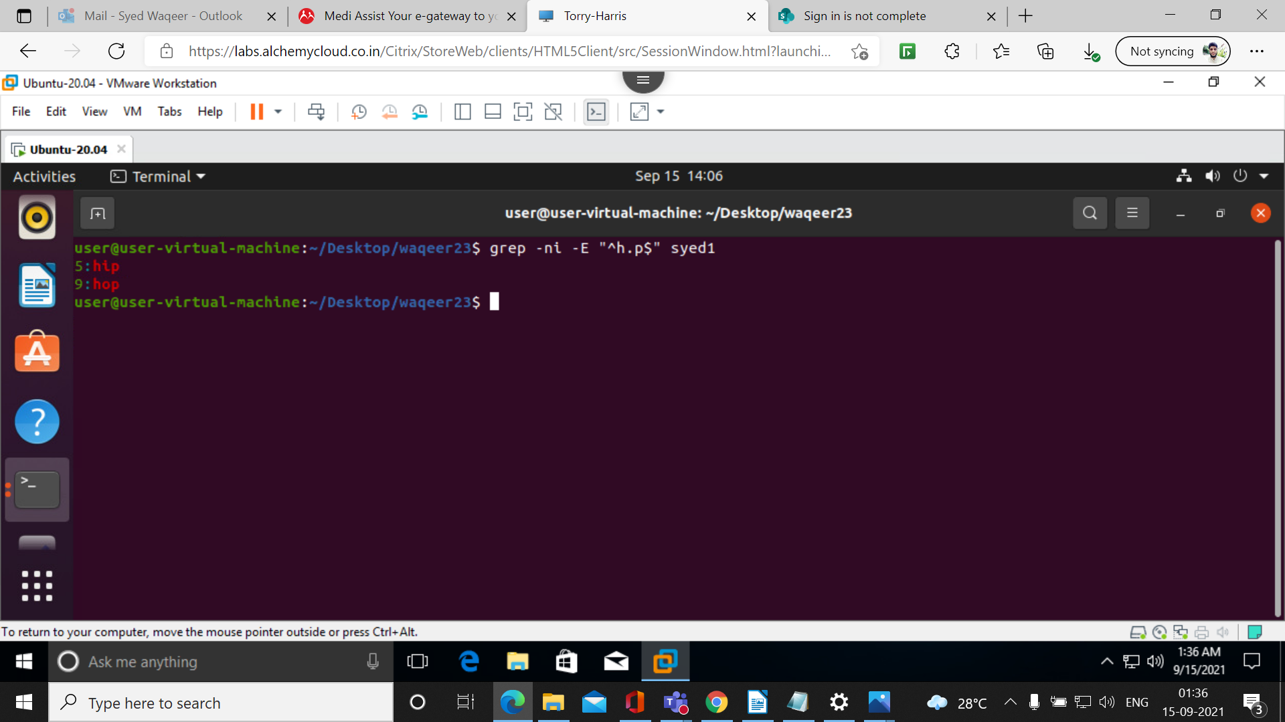

19. \ (backslash):
Ignores the special meaning of the character following it

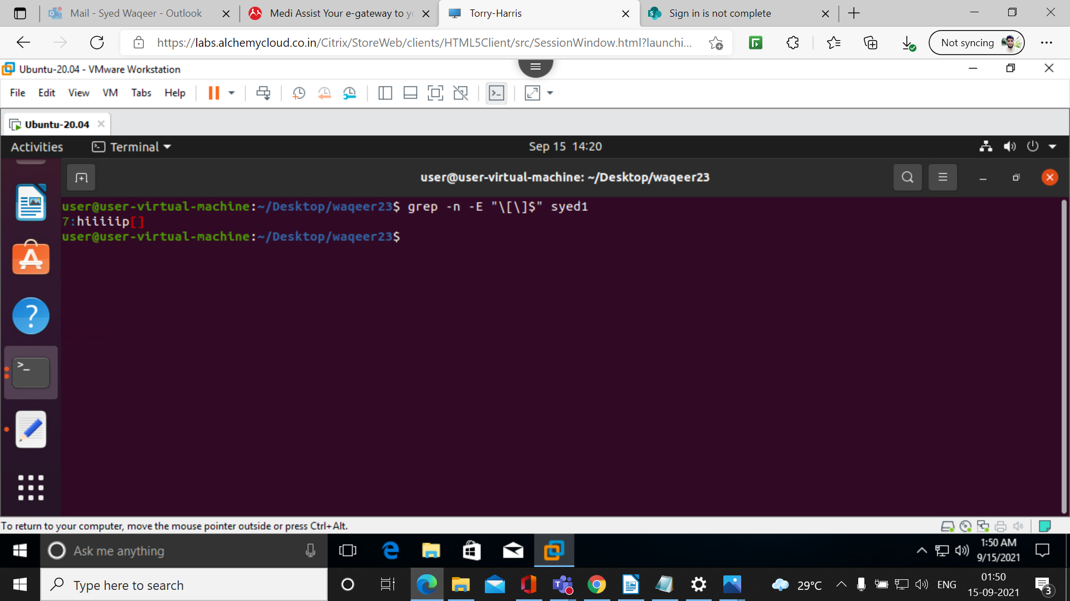
20. *:
zero or more occurrences of the previous character

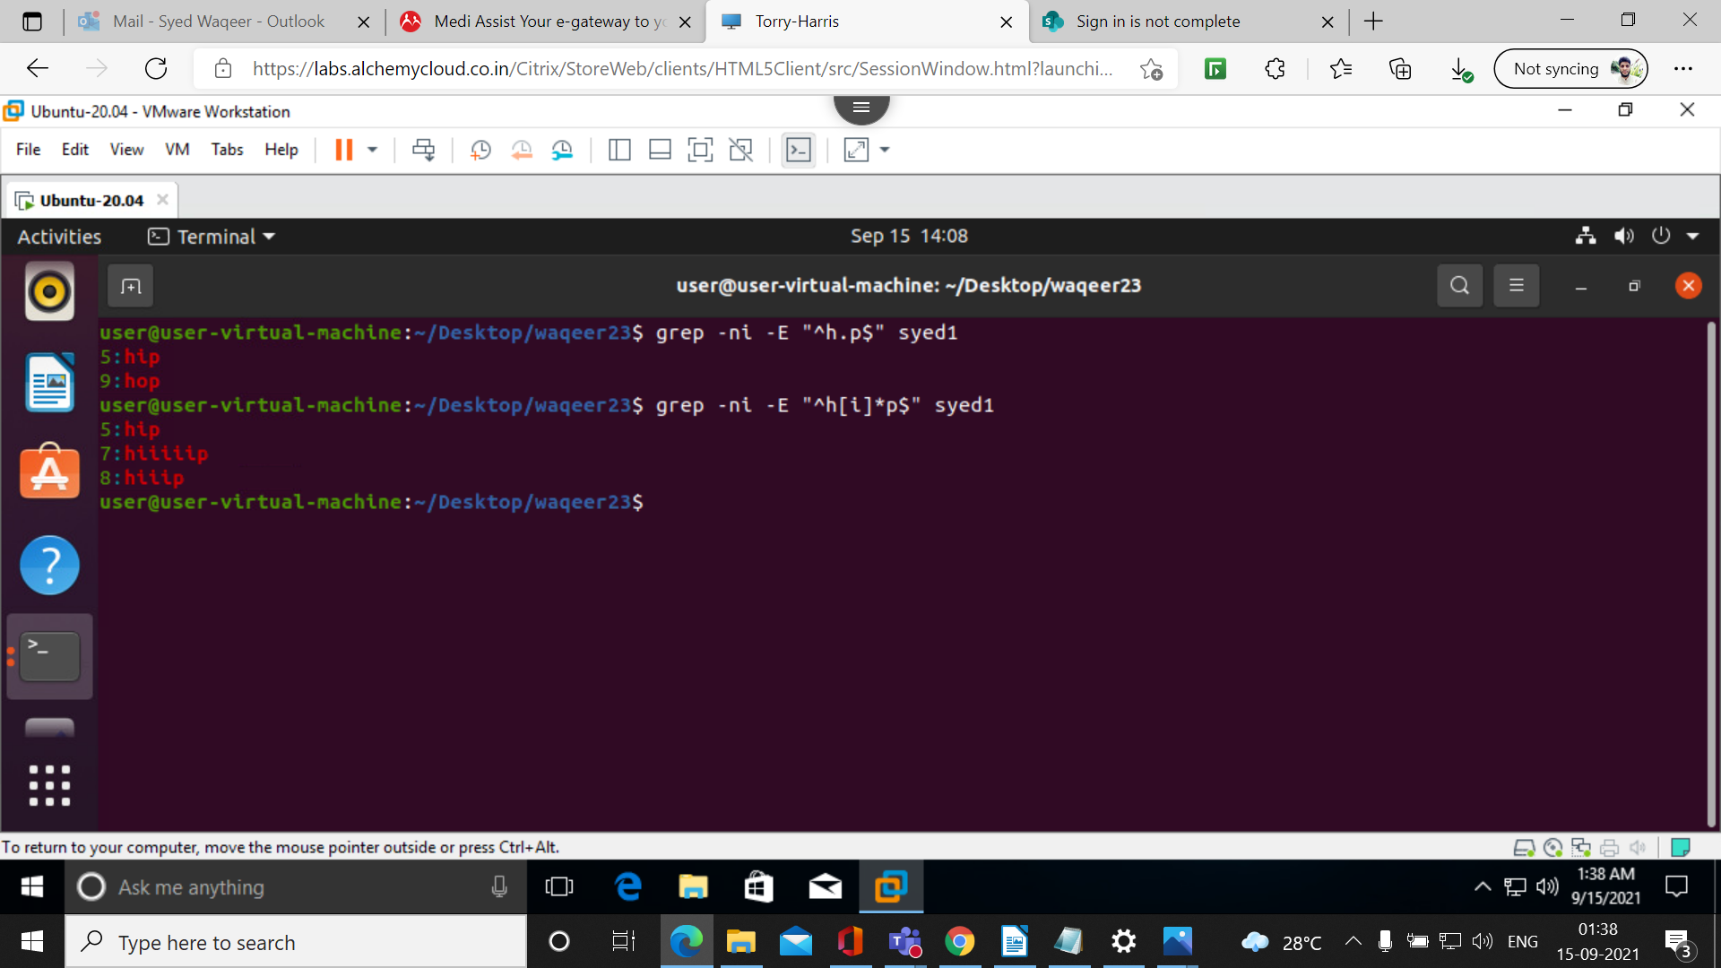

21. (dot).*:
Nothing or any numbers of characters.

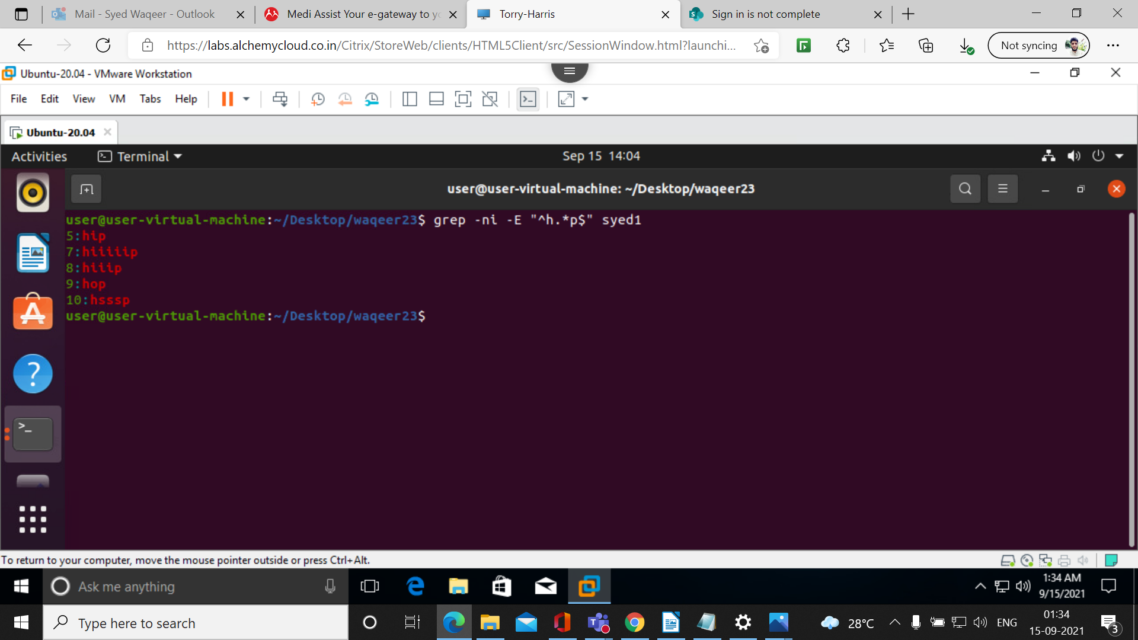
22.cut -c 1,4 filename

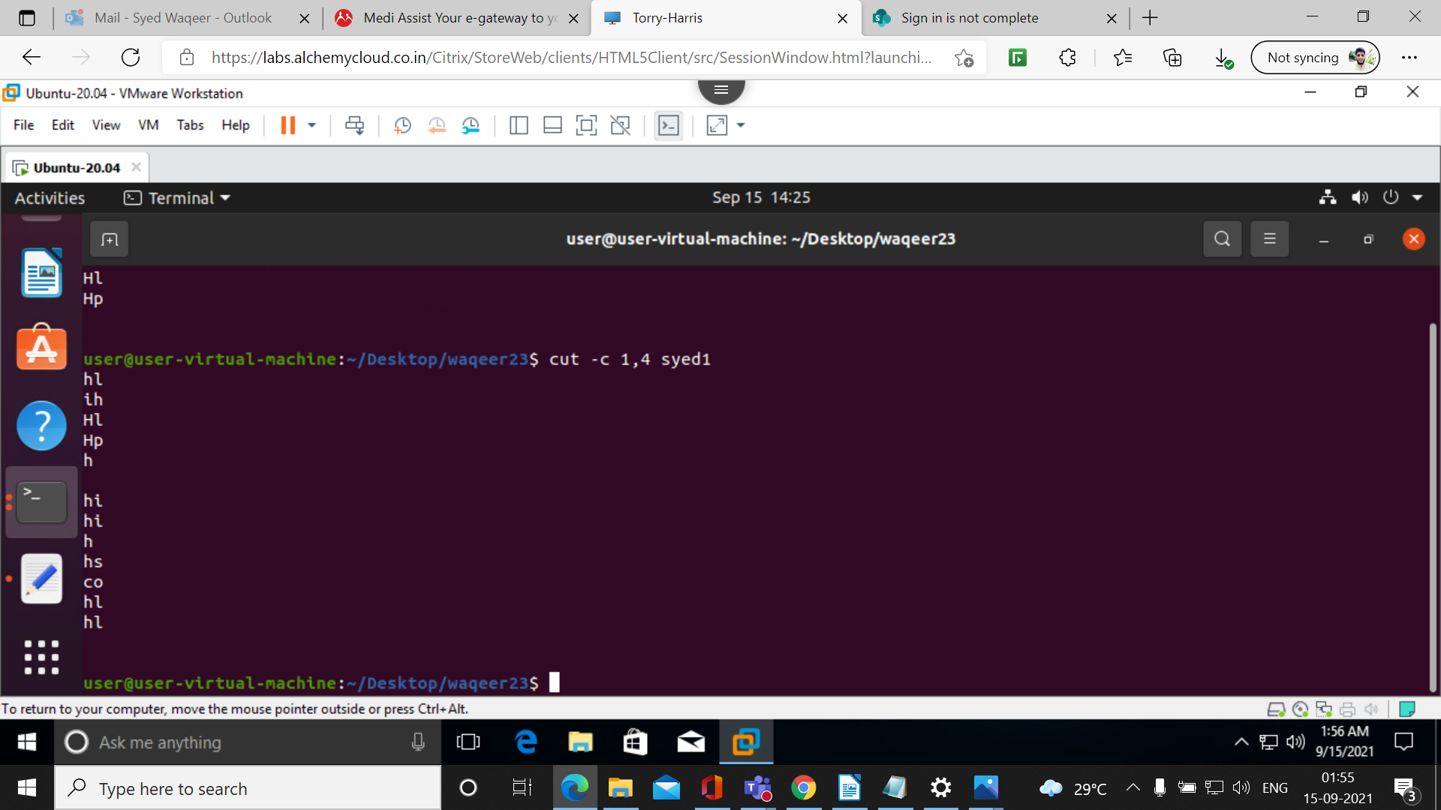

23.cut -c 5- filename

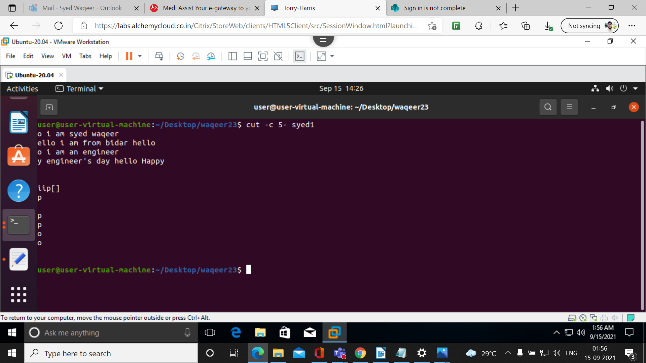
24.cut -c -5 filename

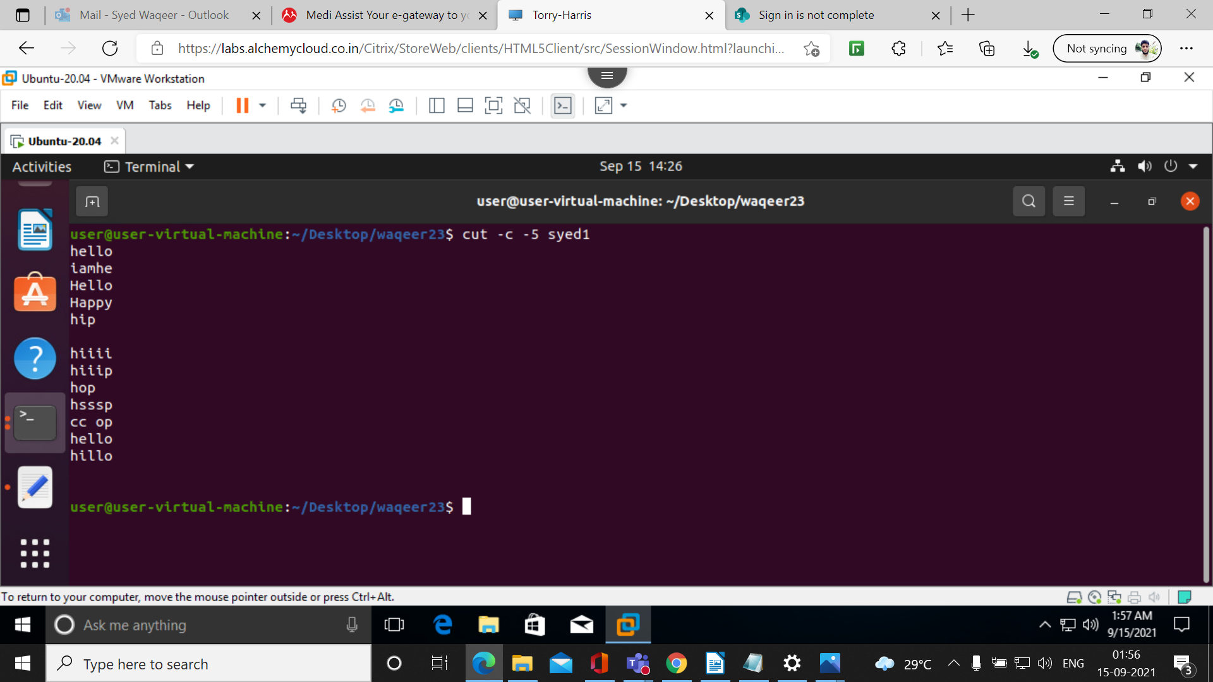

25.cut -c 4-9 filename

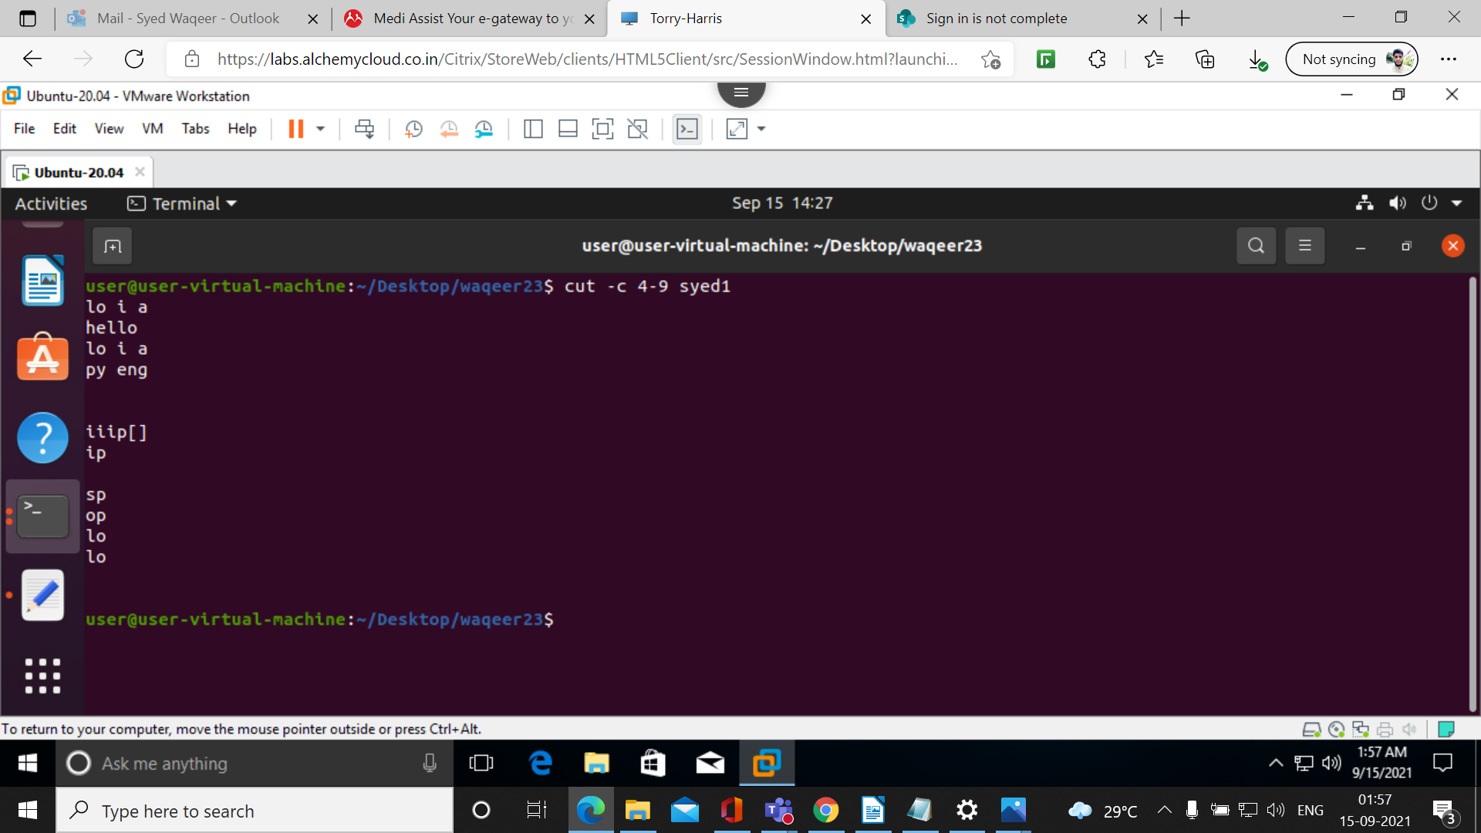
26. cut -d ‘s’ -f -2 filename

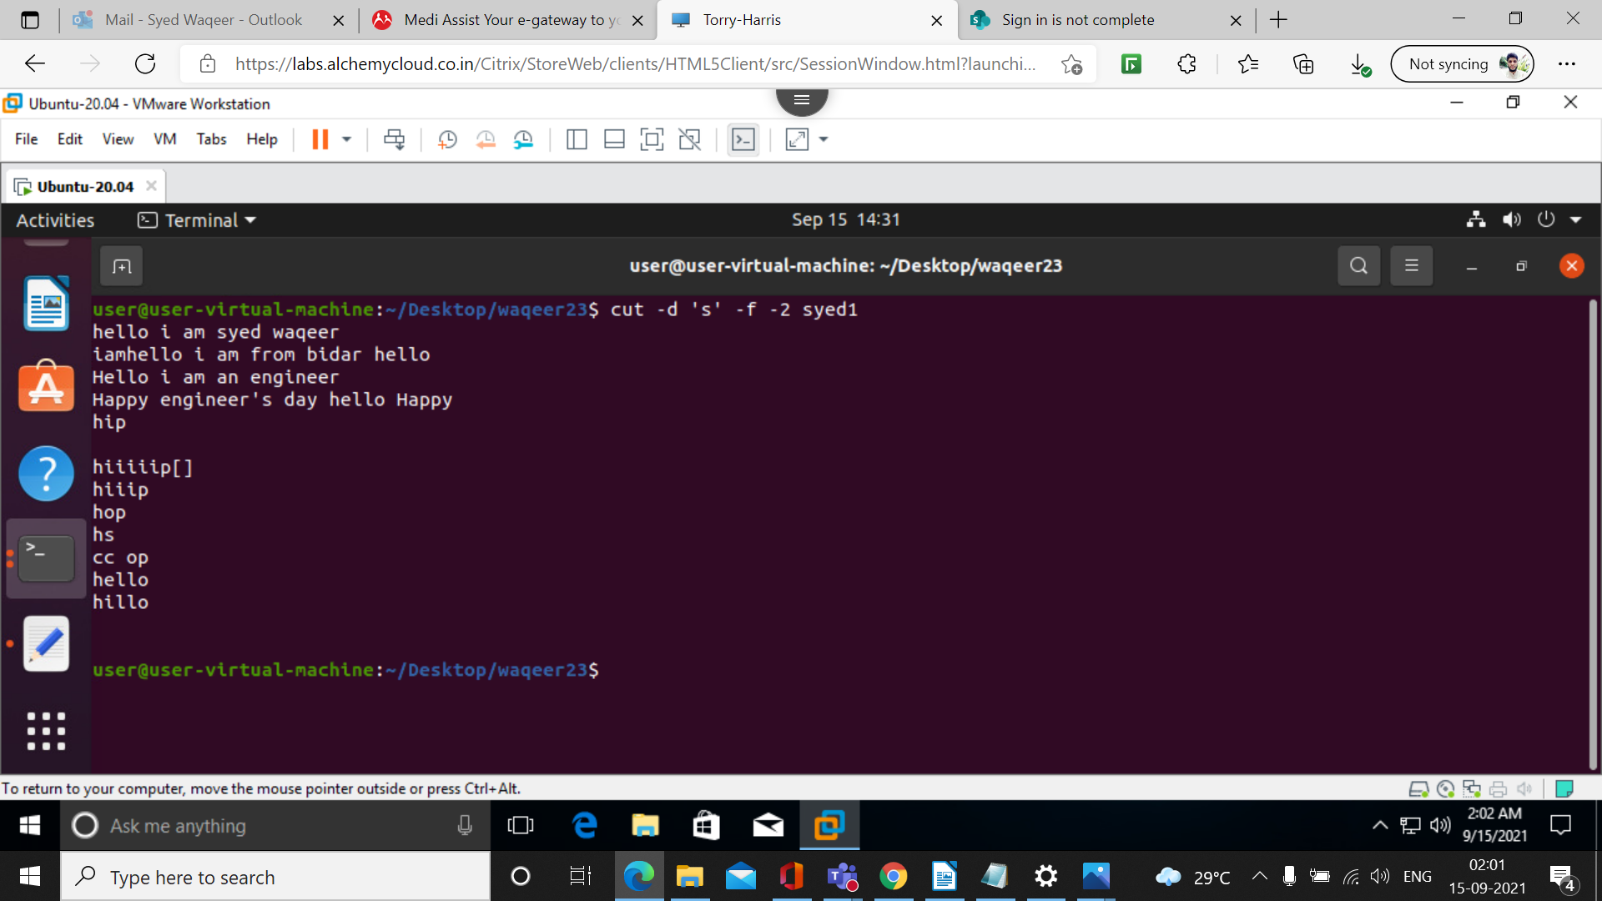

27.cut -d ‘s’ -f 1-4 filename

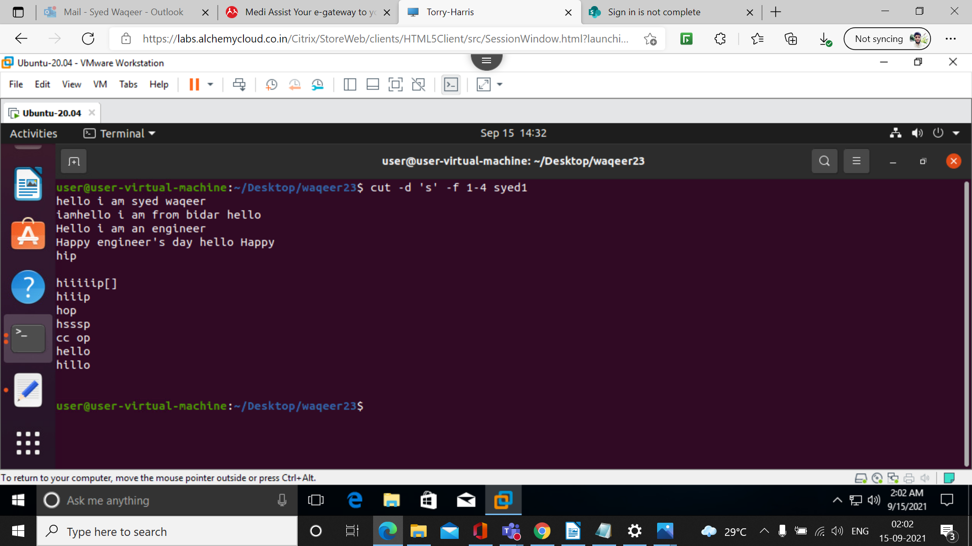
28. cut -d ‘ ’ -f 1-3 filename

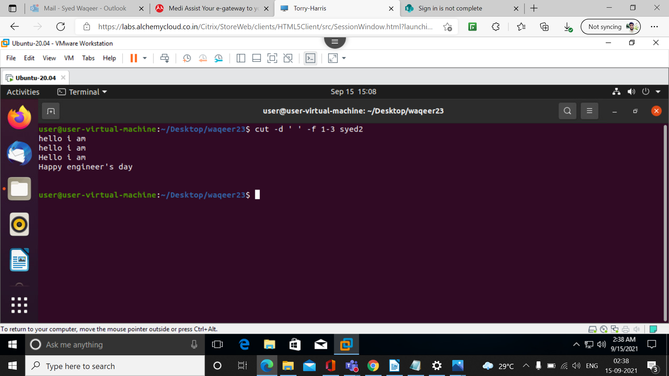

29. cut –complement -c 1,5 filename

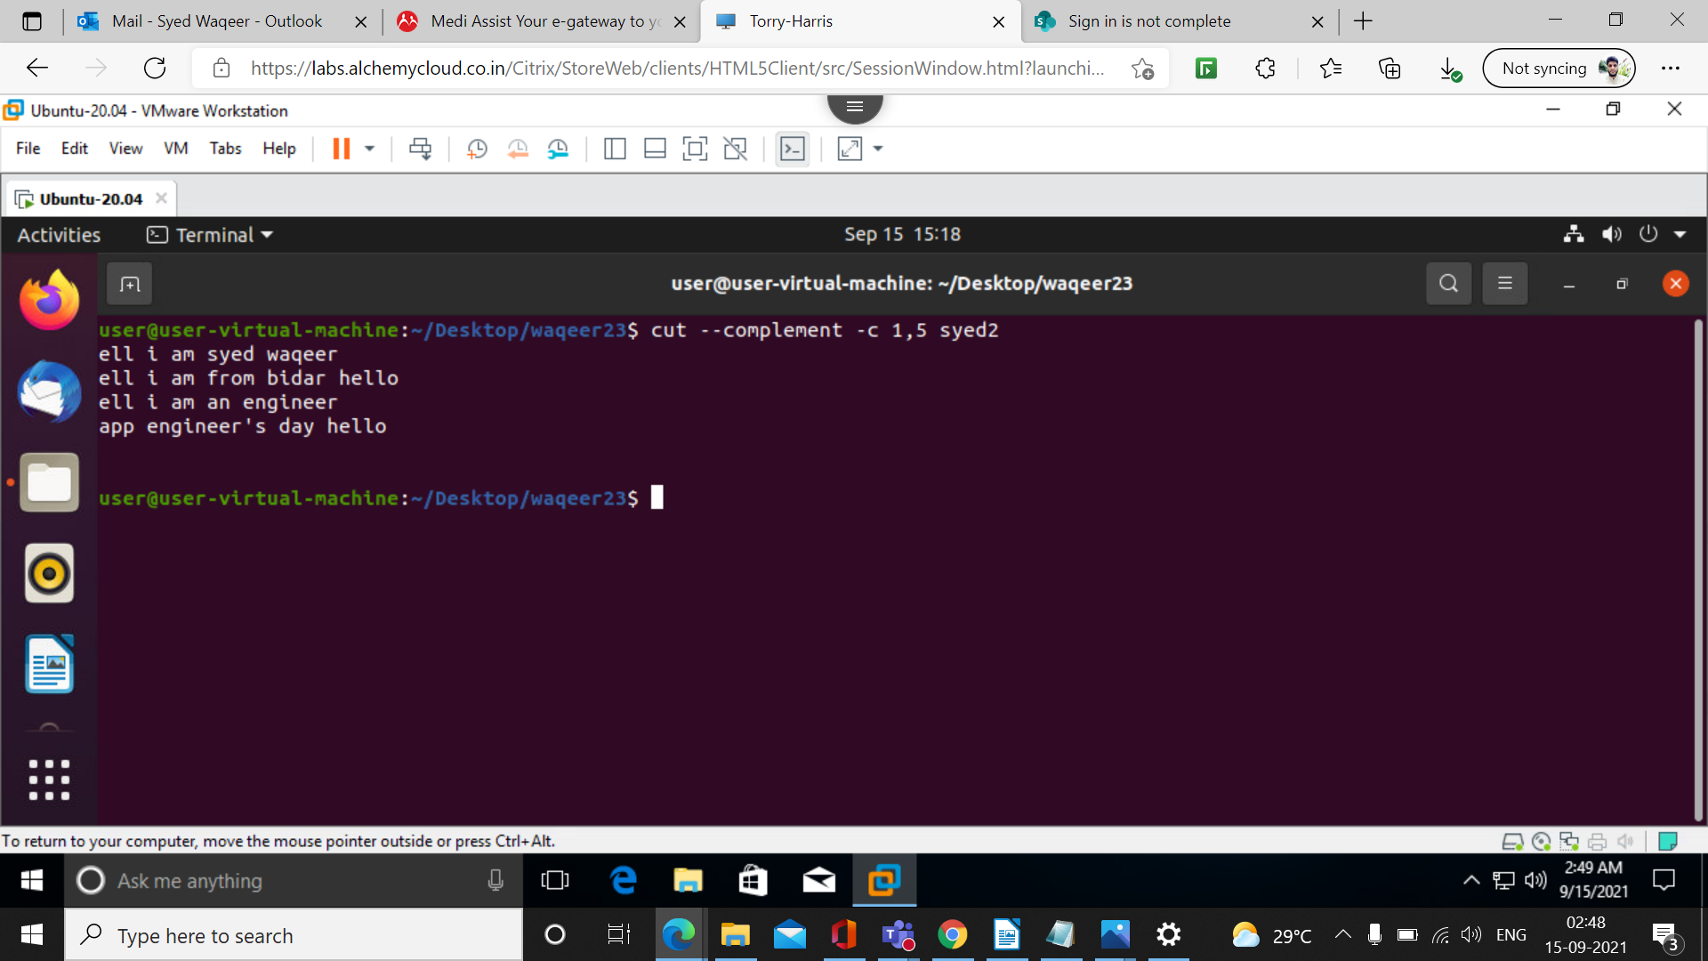
30. cut –complement -c 5- filename

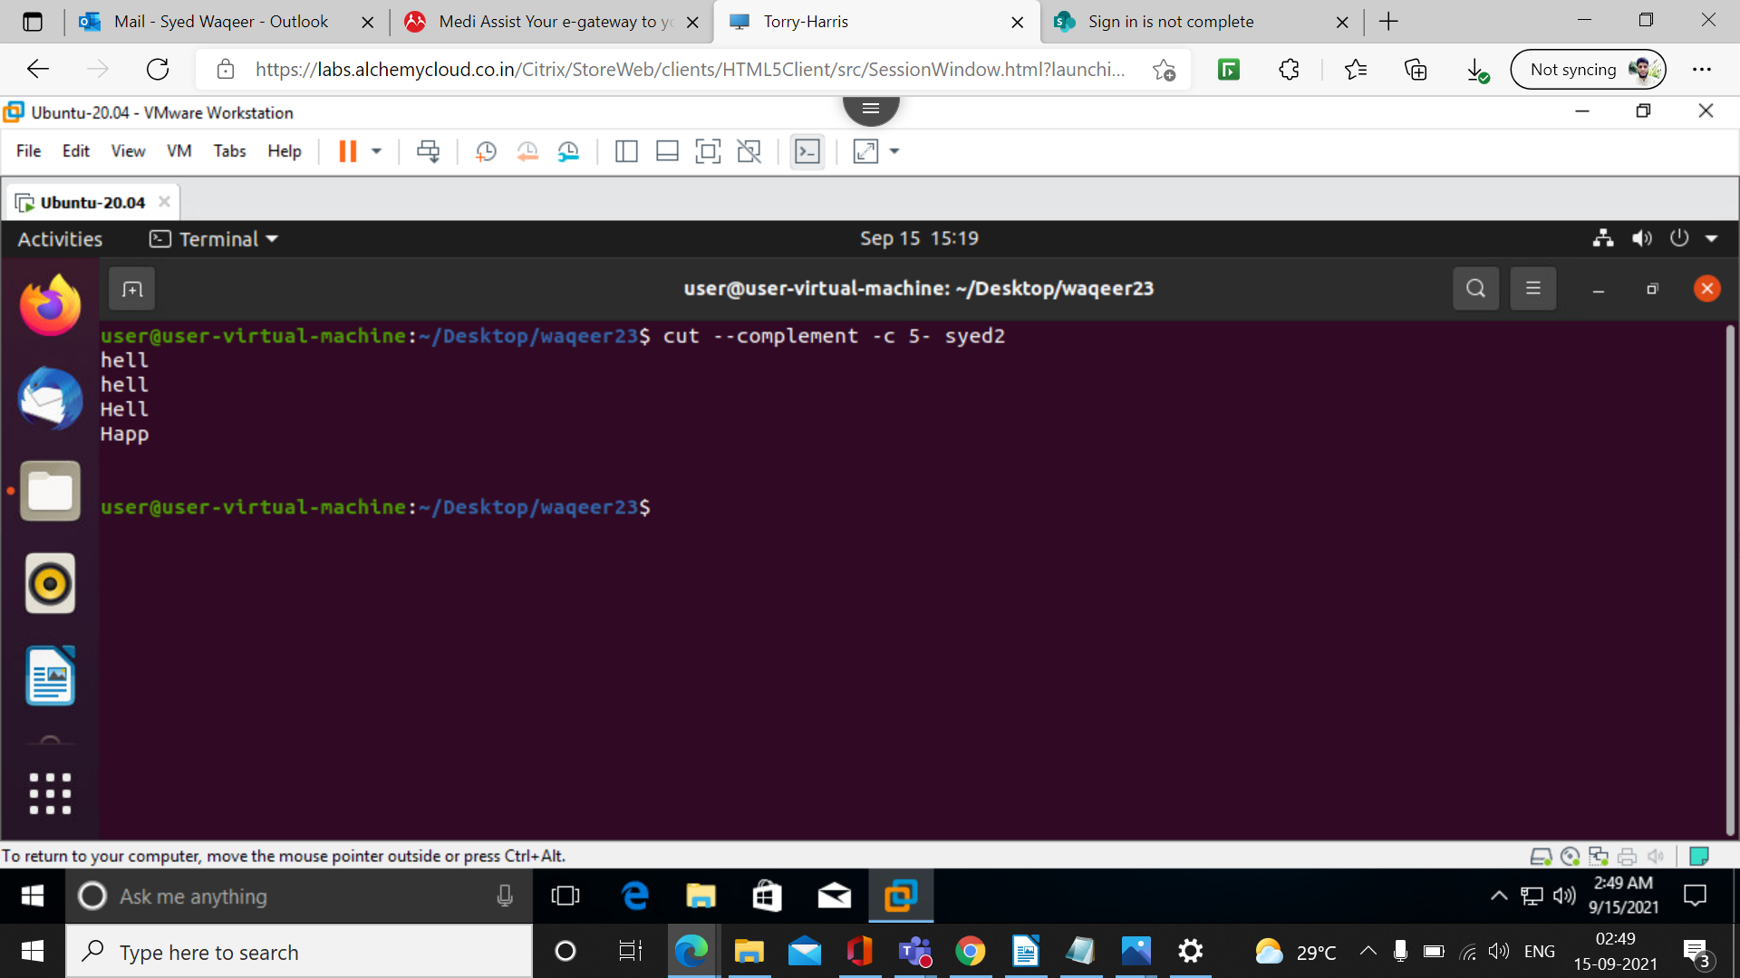

31. cut –complement -d ‘ ‘ -f 1 filename

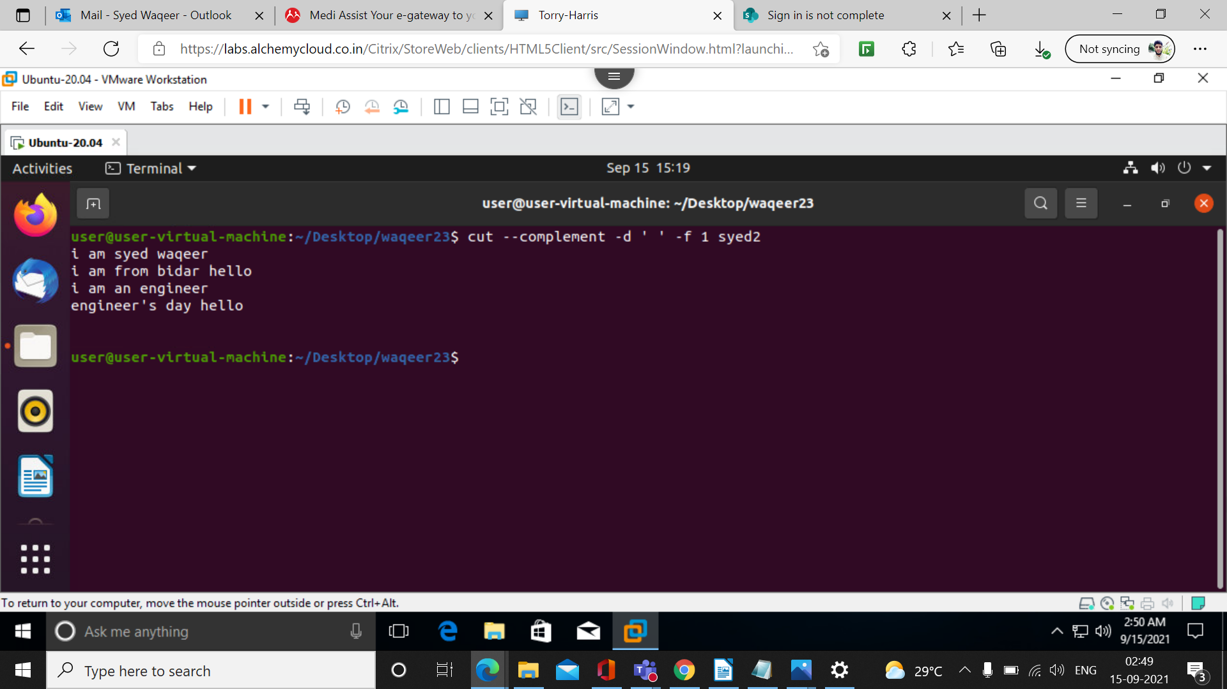
32. cut –complement -b 1 filename

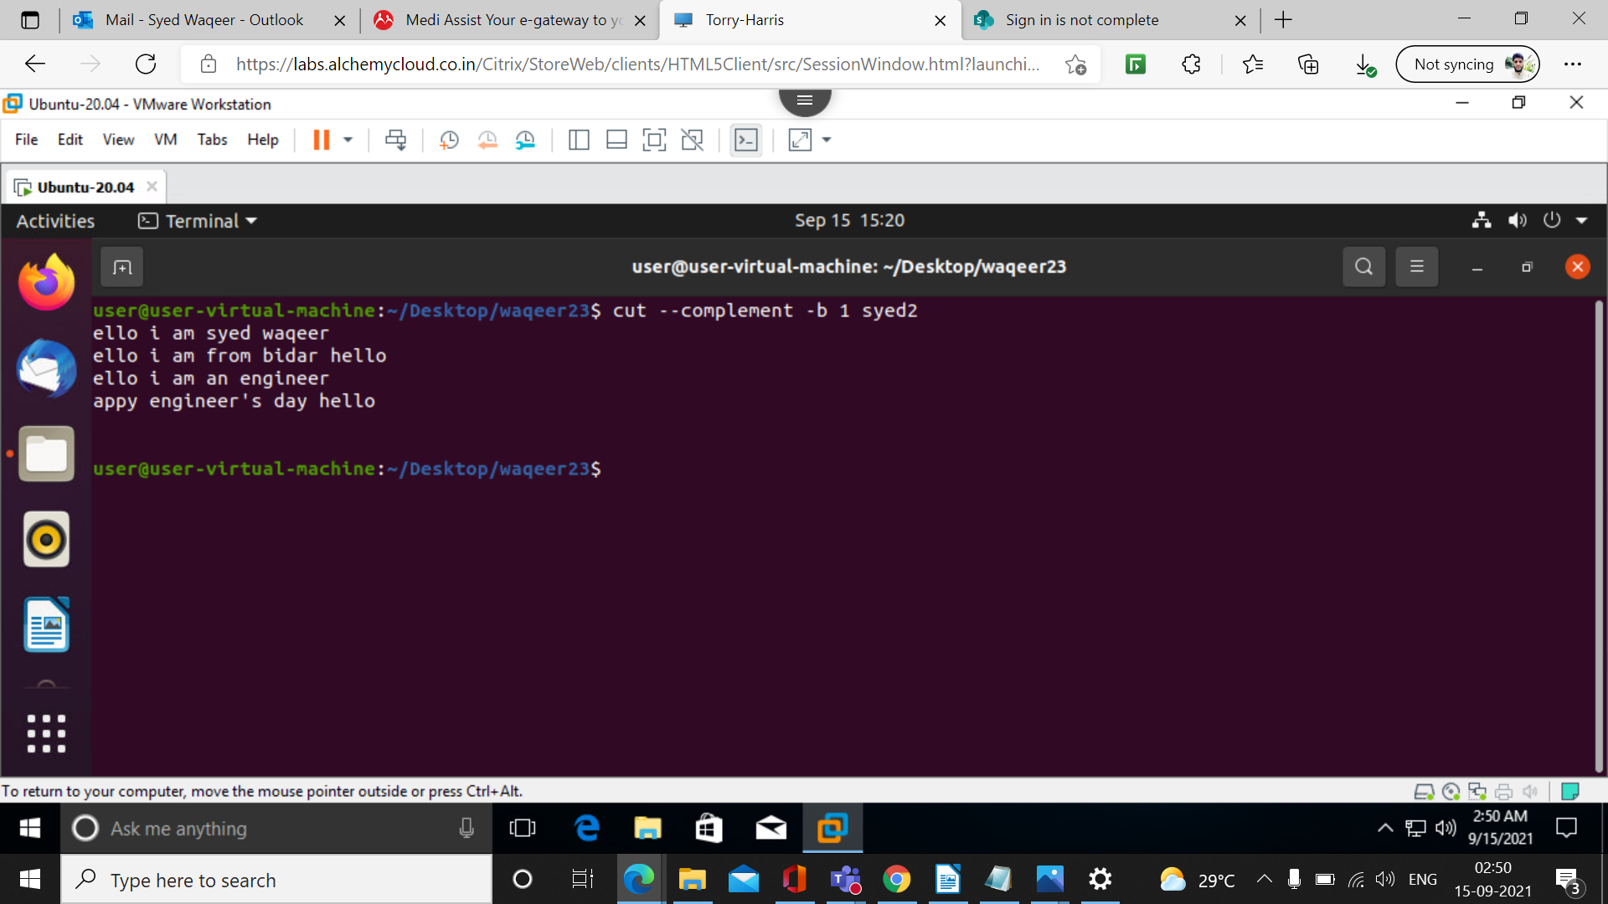

33. cut –complement -b 1-5 filename

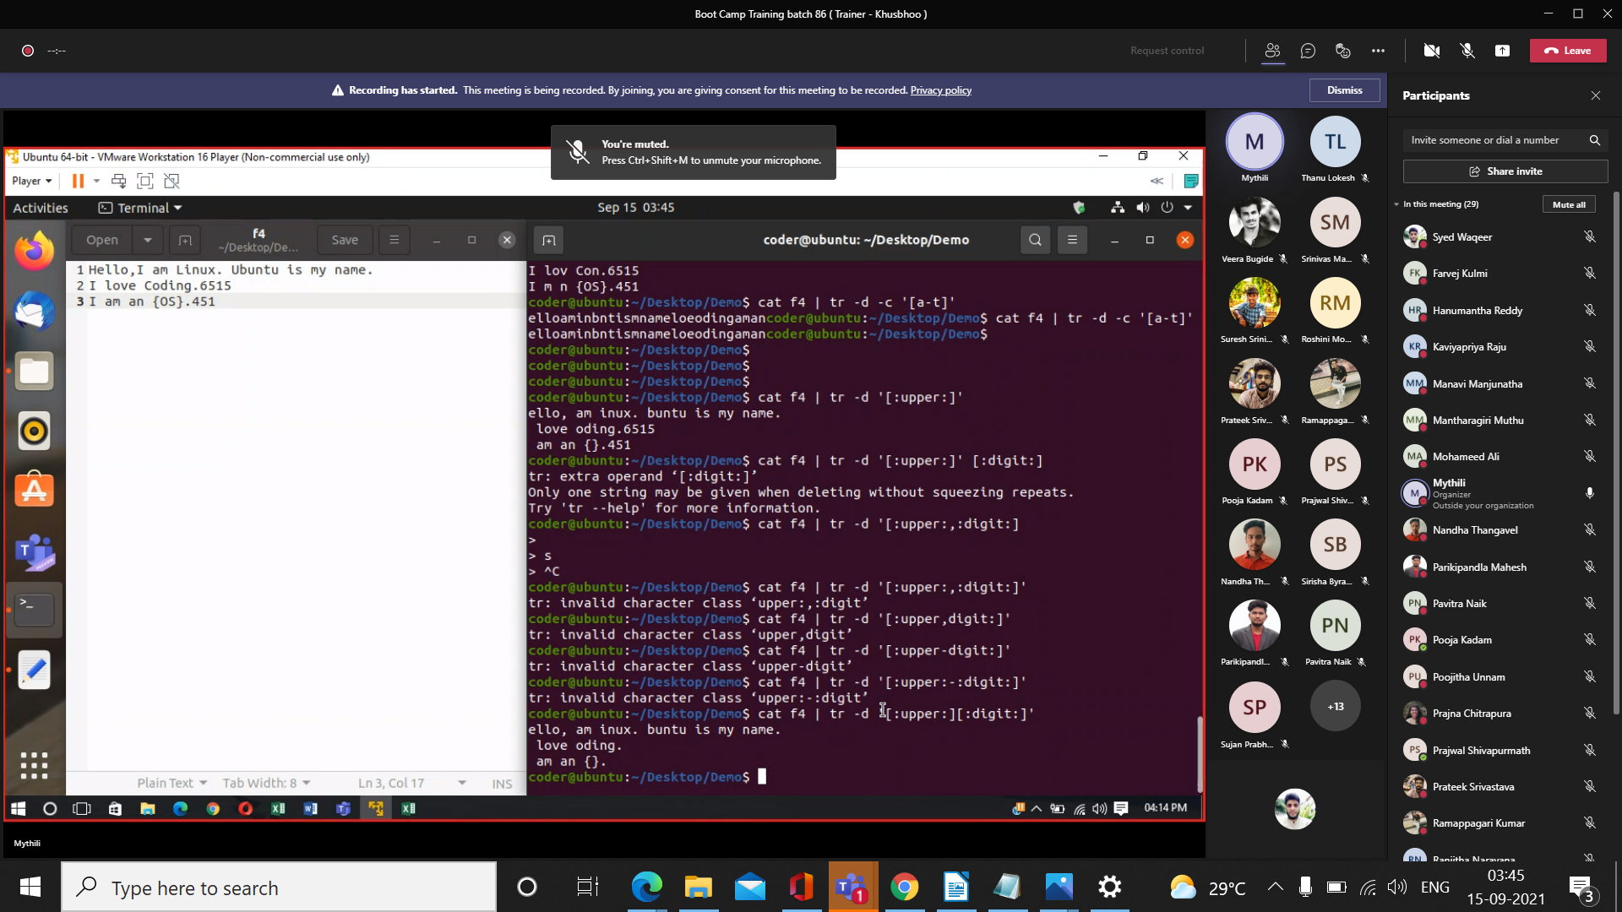
34. cut -d ‘ ‘ -f 1-2 filename –output -delimiter=’*’

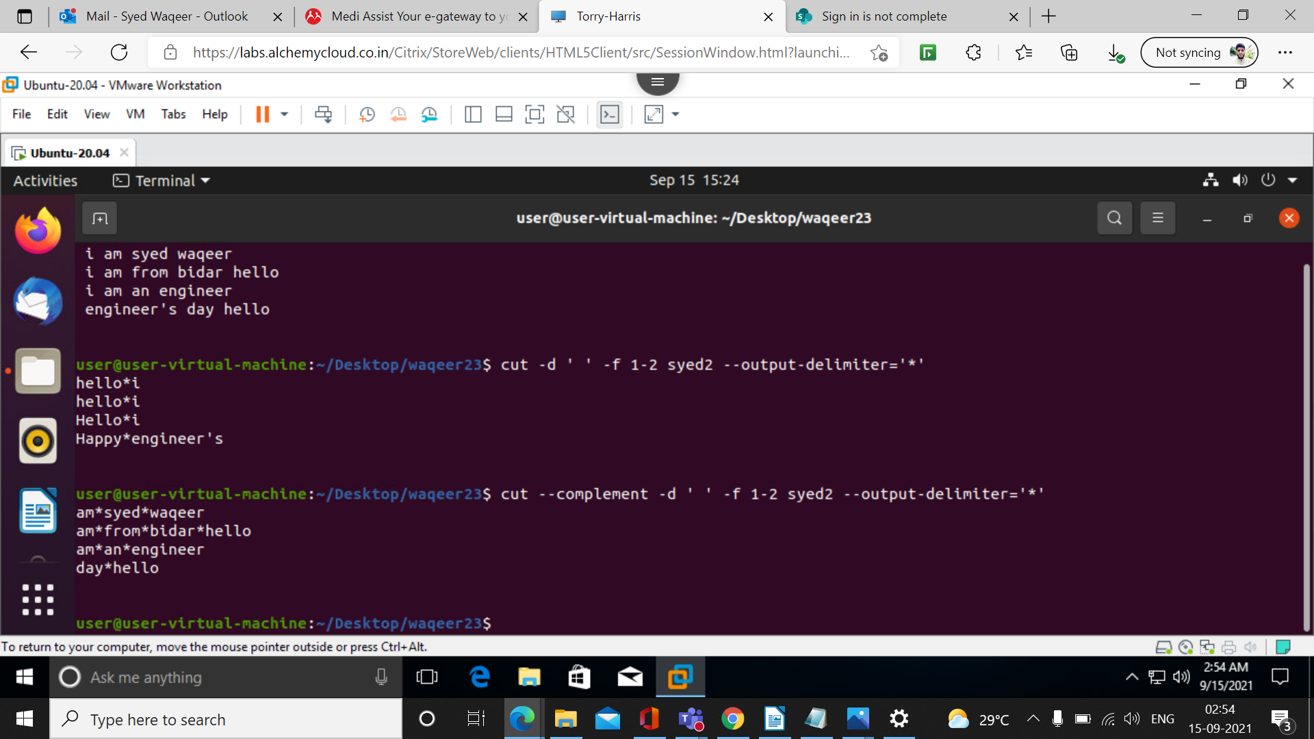

36. cut –complement -d ‘ ‘ -f 1-2 filename –output -delimiter=’*’

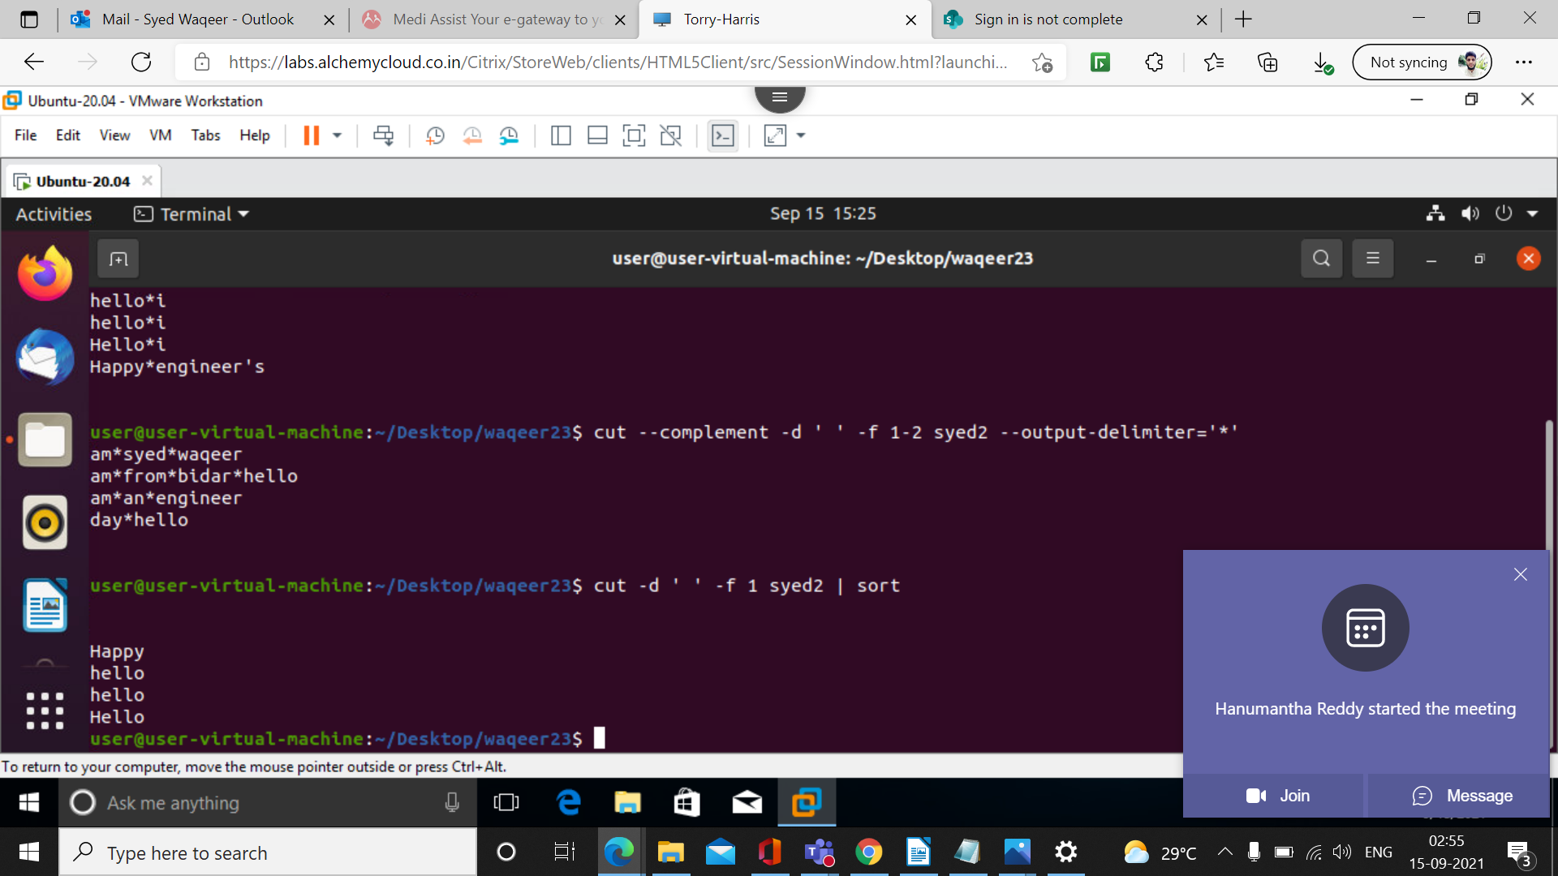
37. cut -d ‘ ‘ -f 1 filename | sort

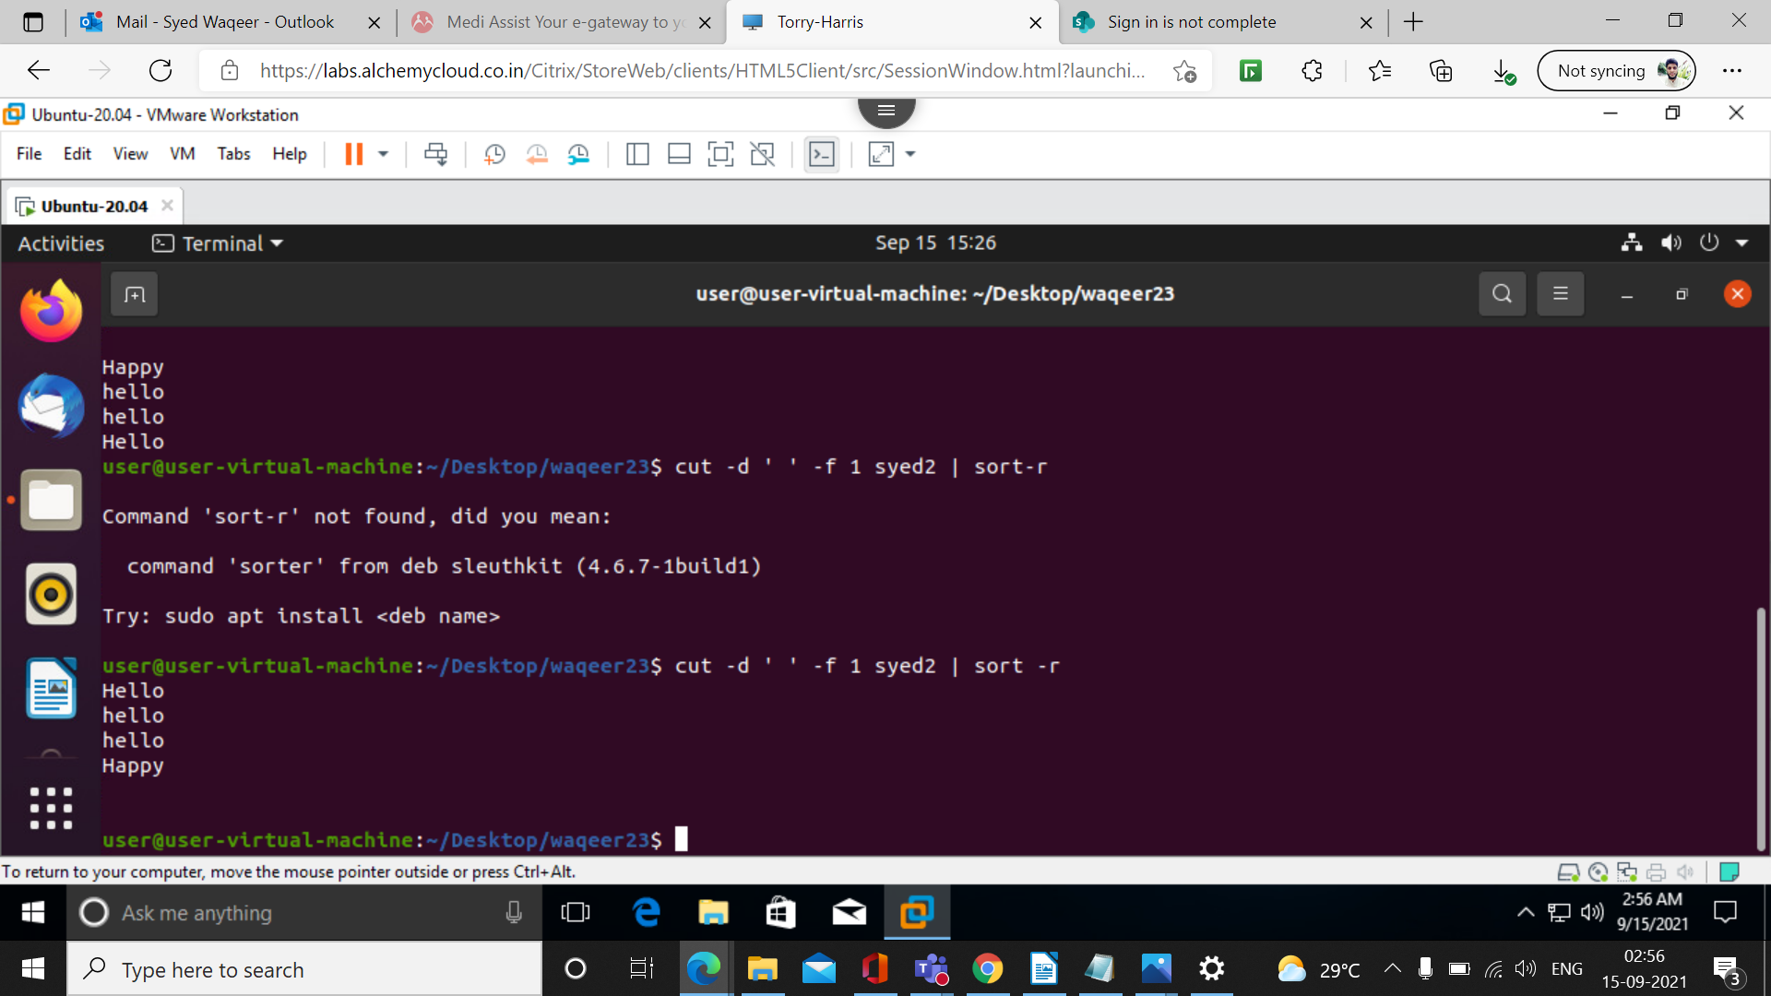

38. cut filename | cut -d ‘ ‘ -f 1-3 | sort -r

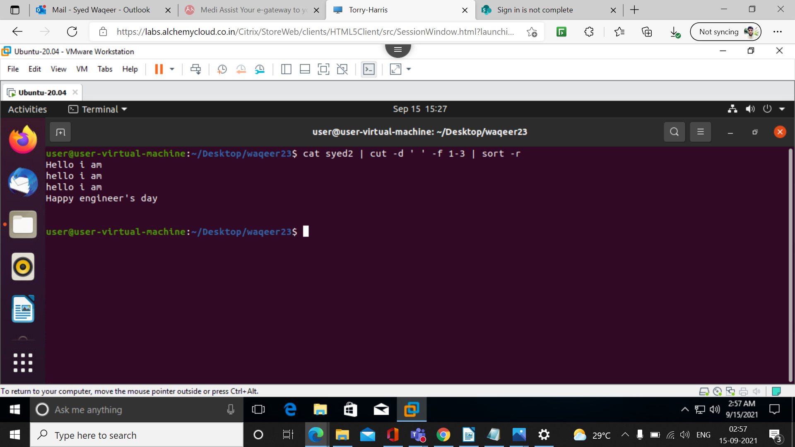
39. cat filename | tr ‘[a-z]’ ‘[A-Z]’

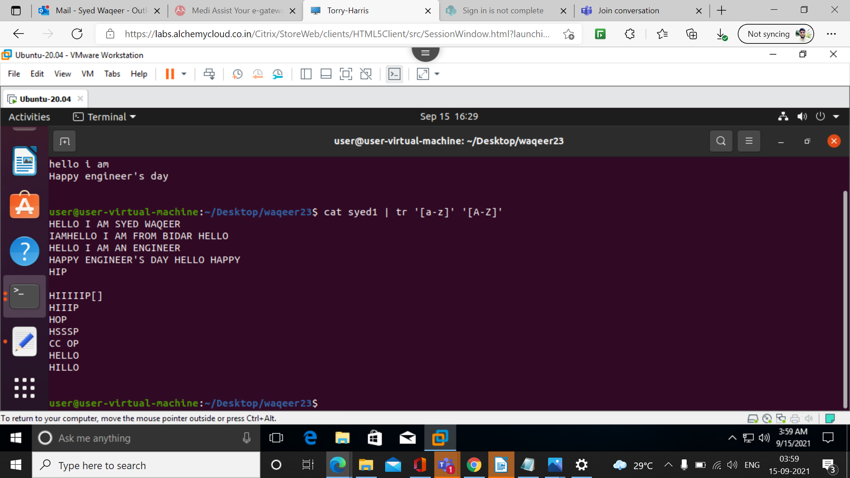

40. cat filename | tr ‘[:upper:]’ ‘[:lower:]’

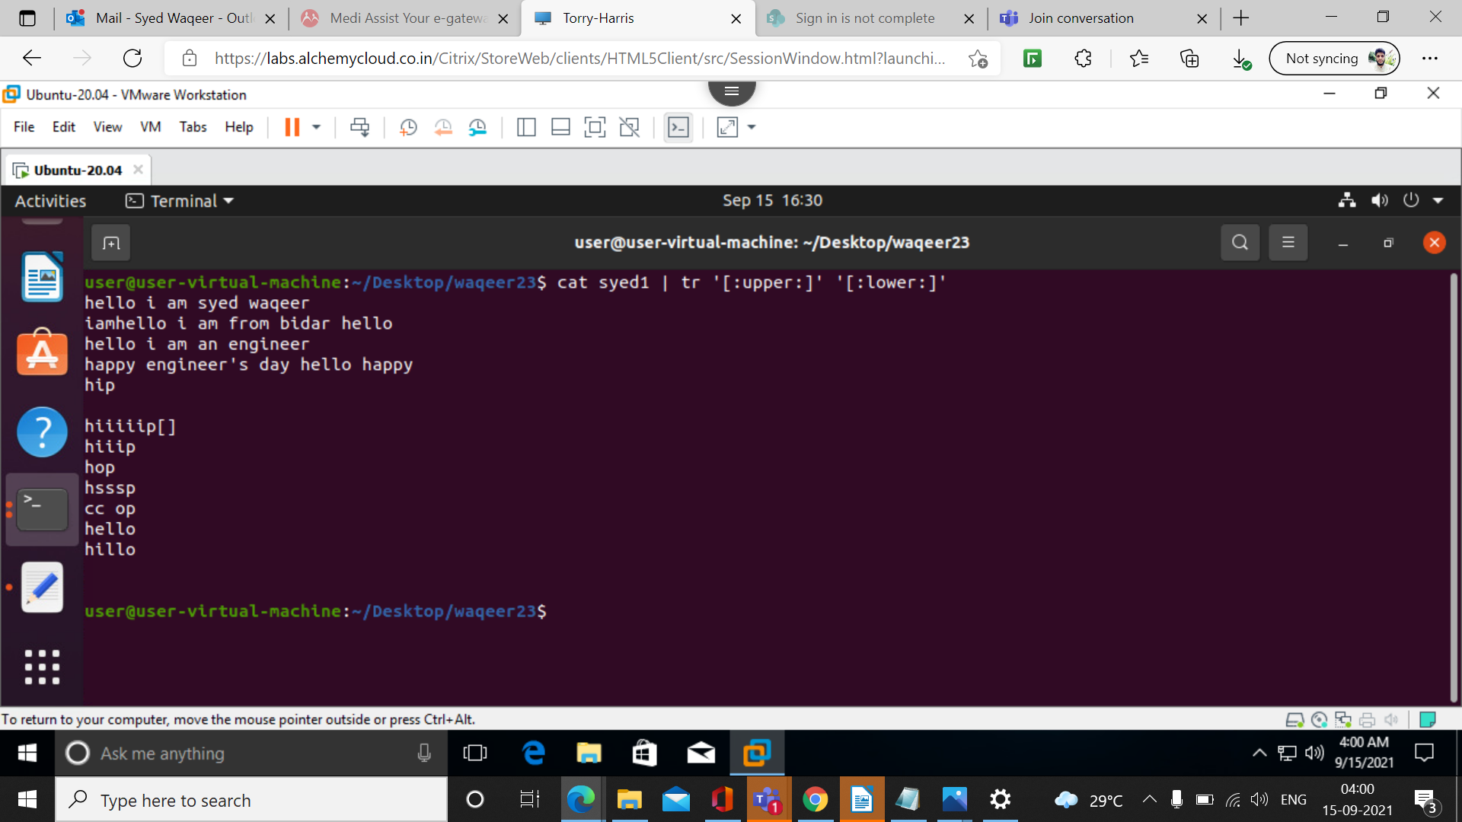
41. echo “Hello World” | tr ‘[:lower:]’ ‘[:upper:]’

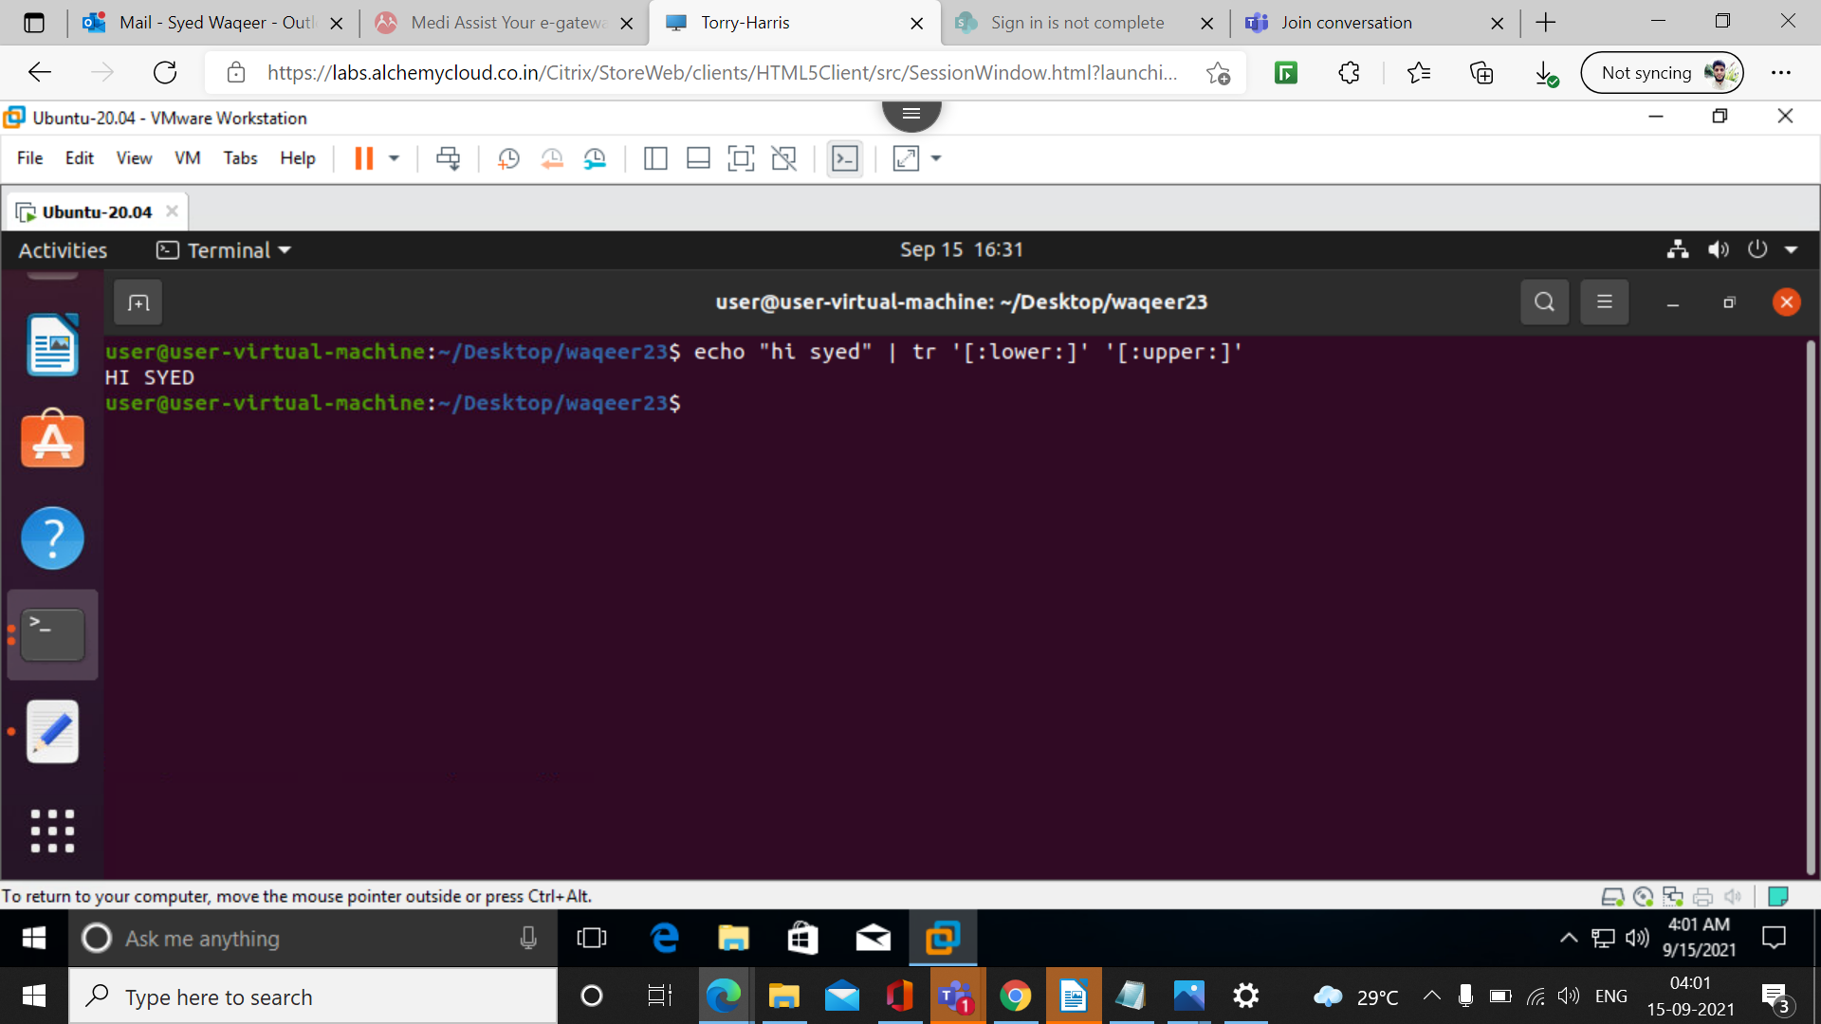

42. echo “Hello World” | tr ‘[:space:]’ ‘\t’

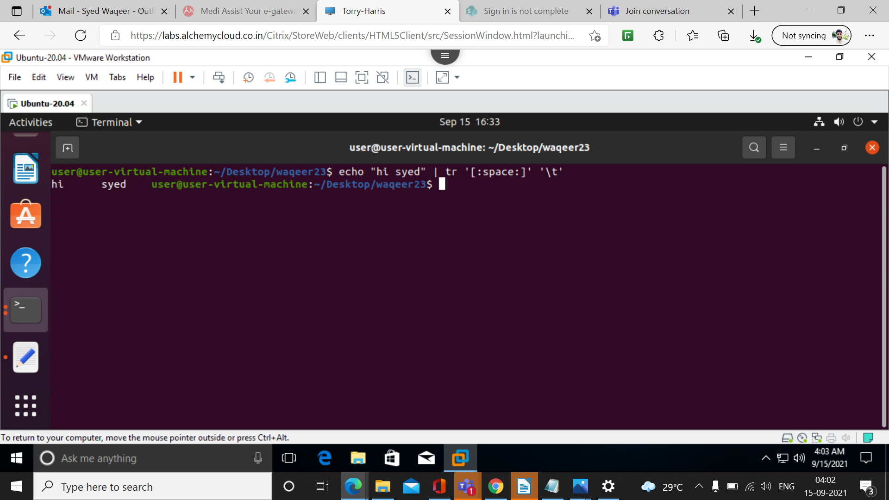
43. cat filename | tr ‘[:space:]’ ‘\n’

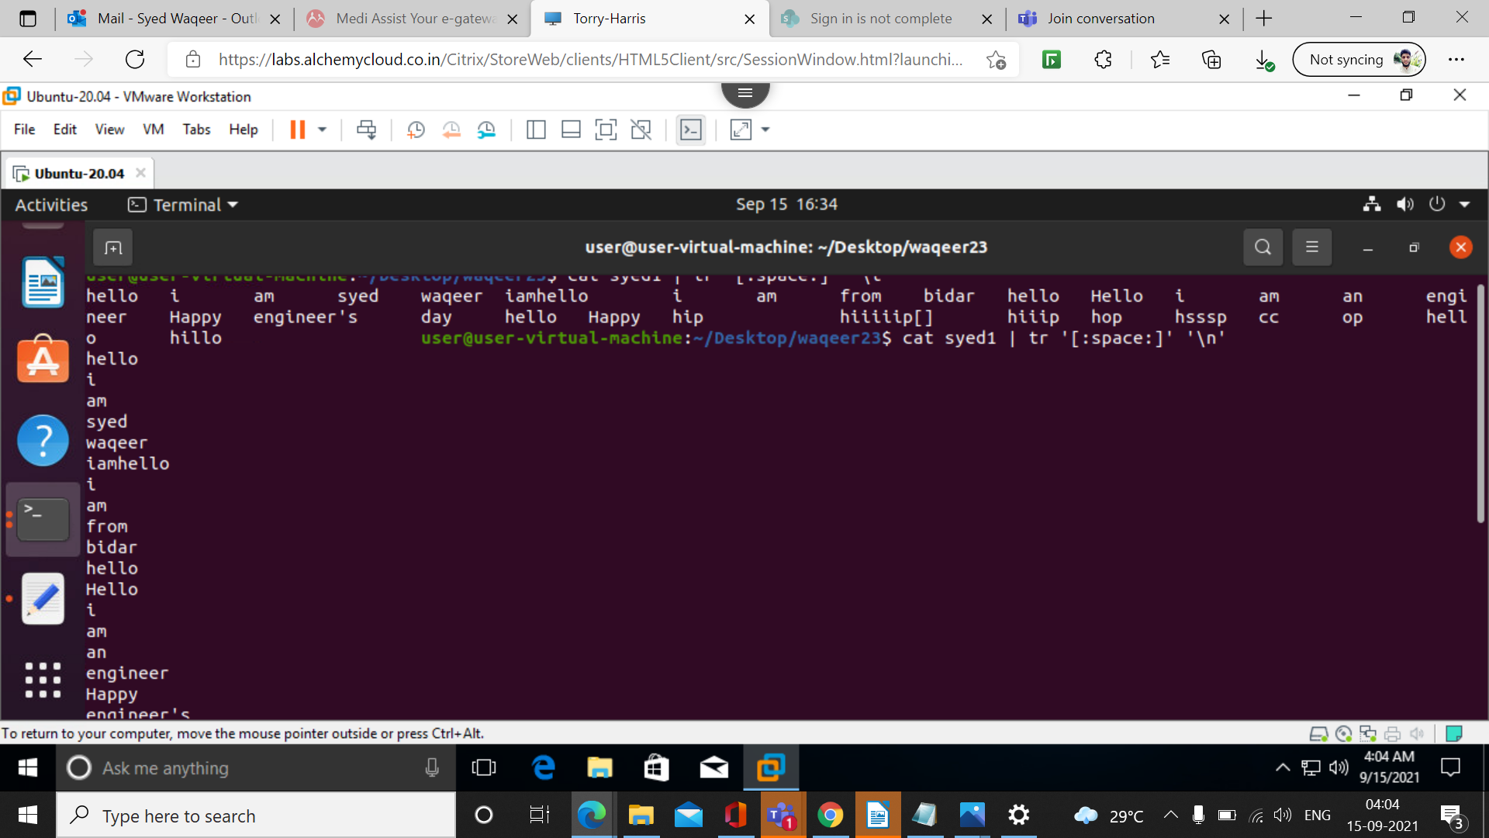

44. cat filename | tr ‘H’ ‘k’

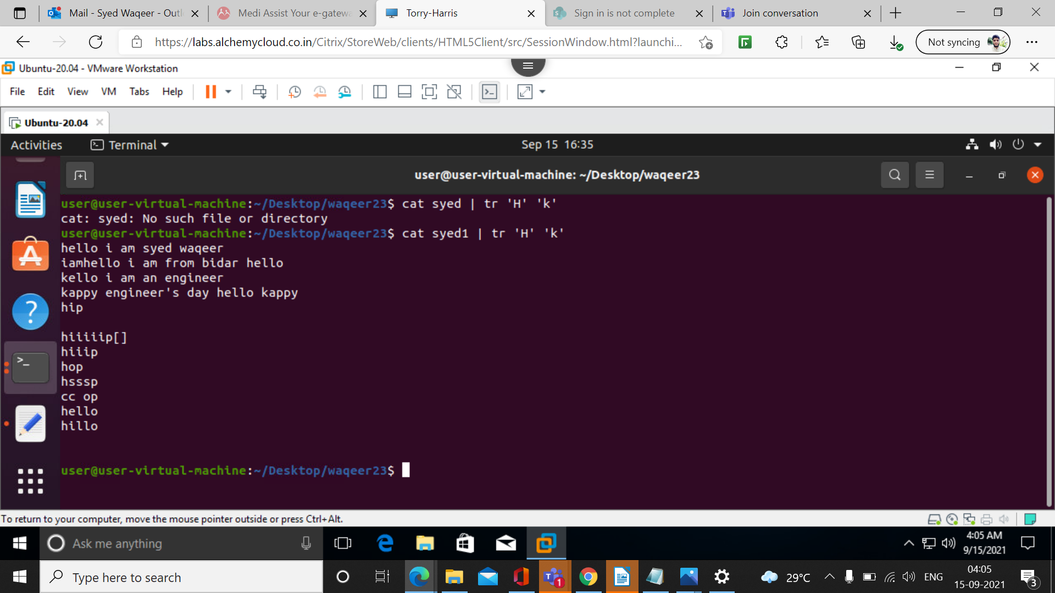
45. cat filename | tr ‘{}’ ‘()’

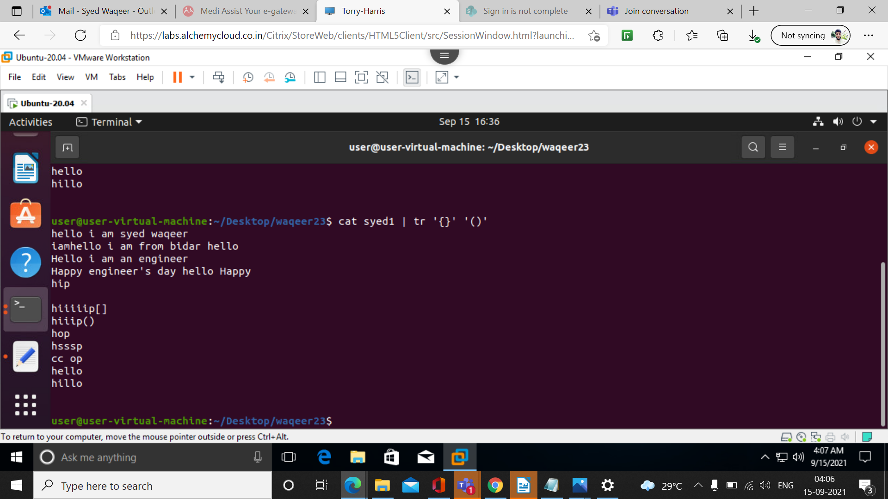

46. cat filename | tr -d ‘[Hel]’

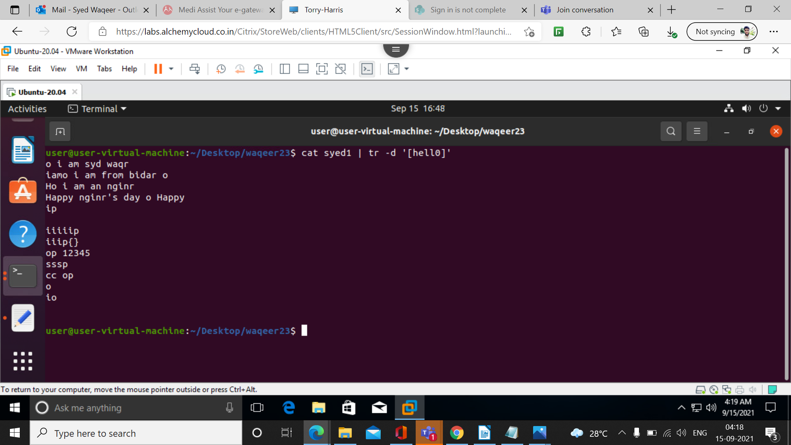
47. cat filename | tr -d ‘[:digit:]’

48. cat filename | tr -d ‘[:upper:]’ ‘[:lower:]’

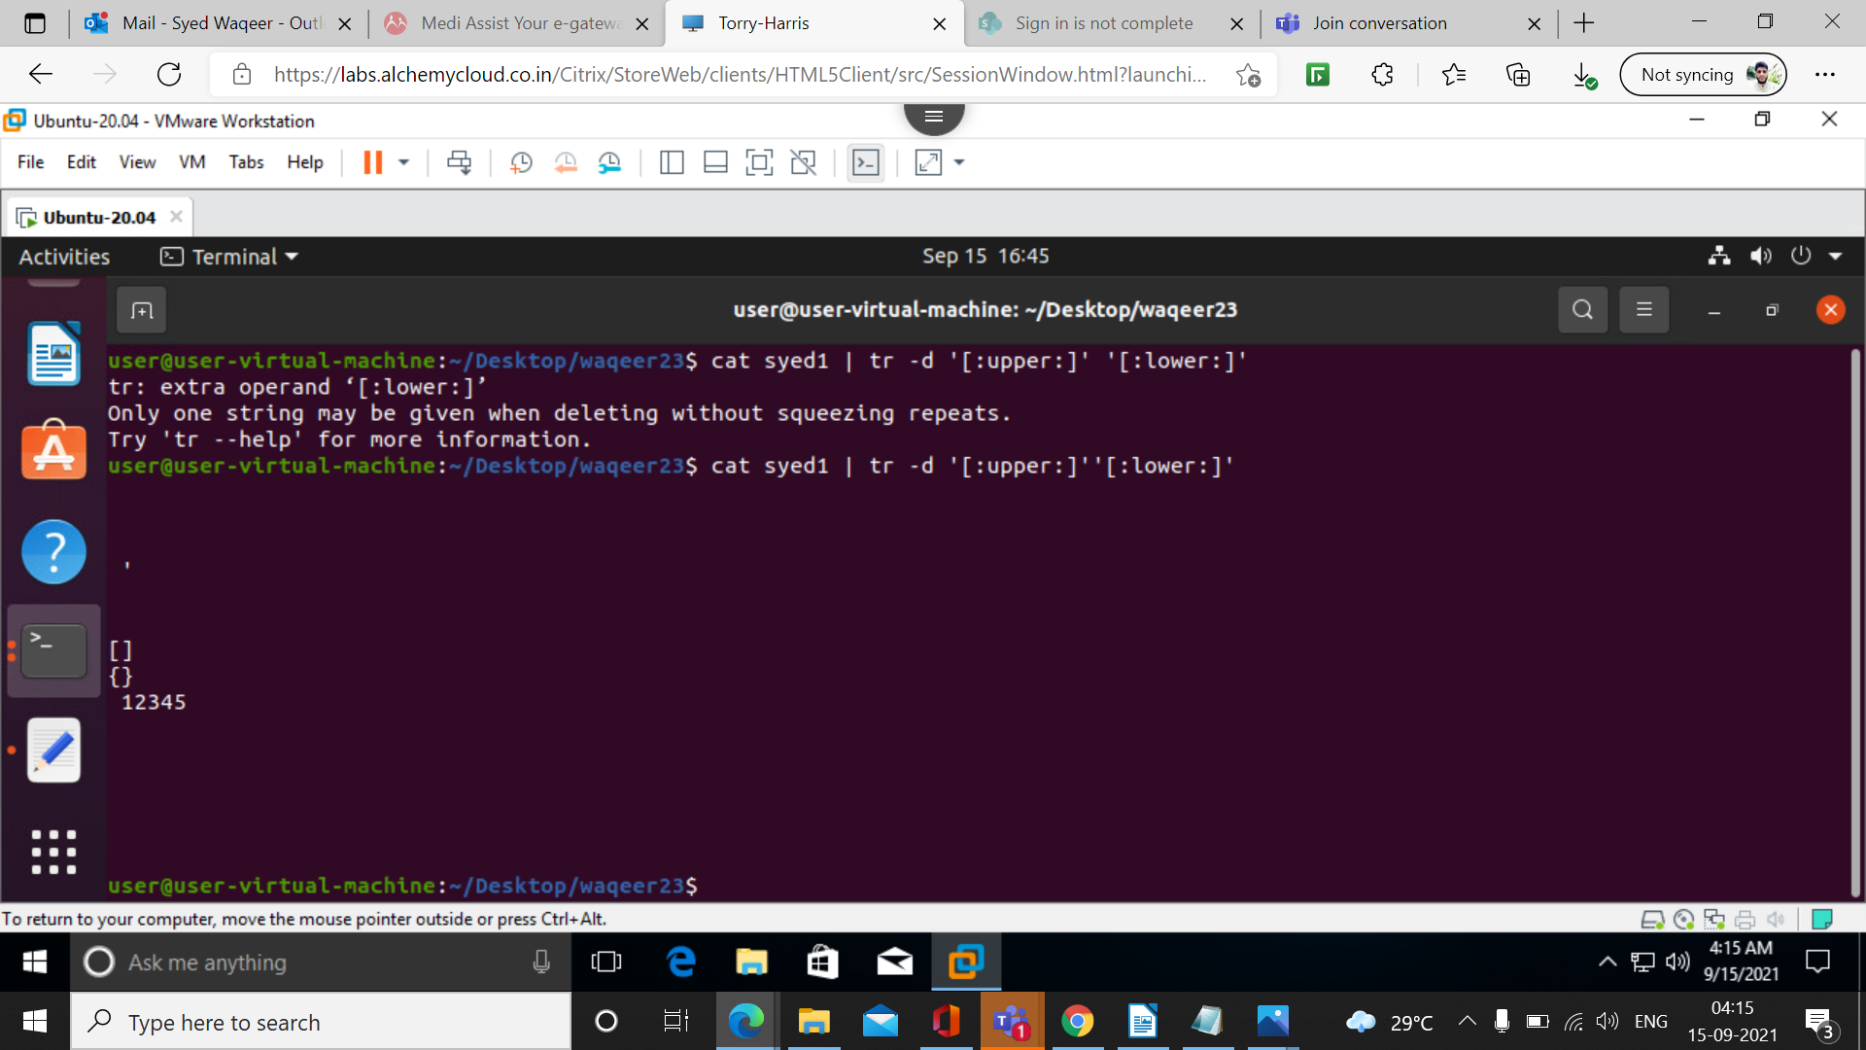
49. more filename
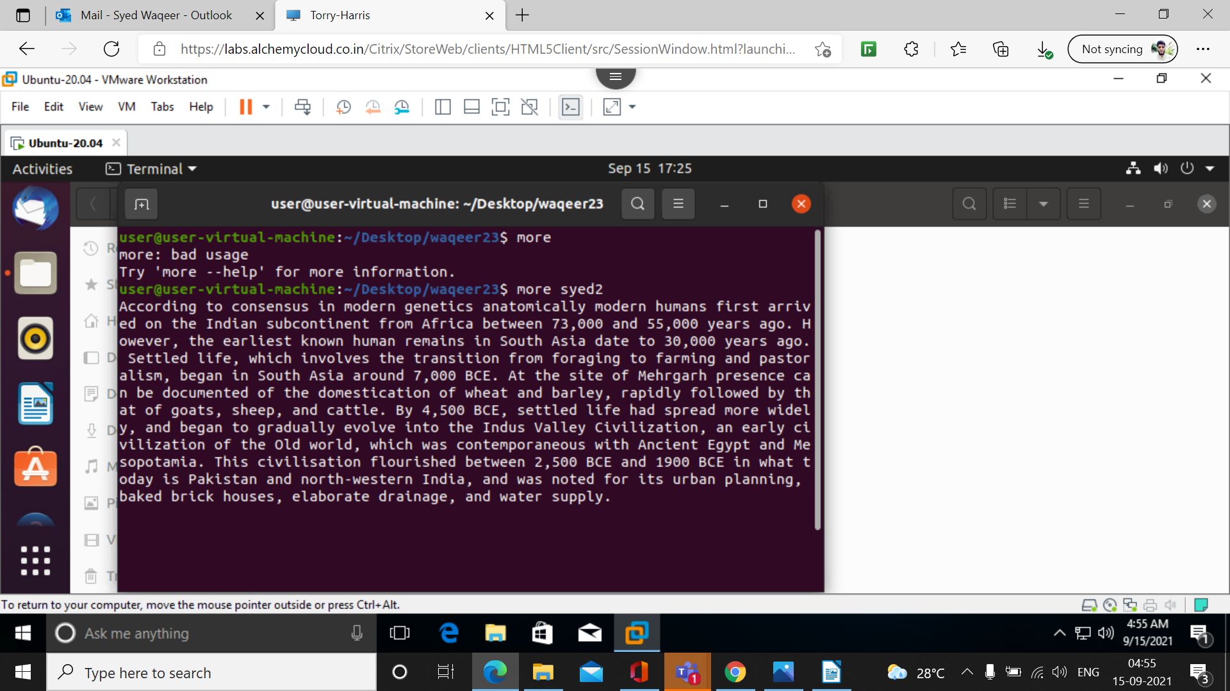

50. more -d filename

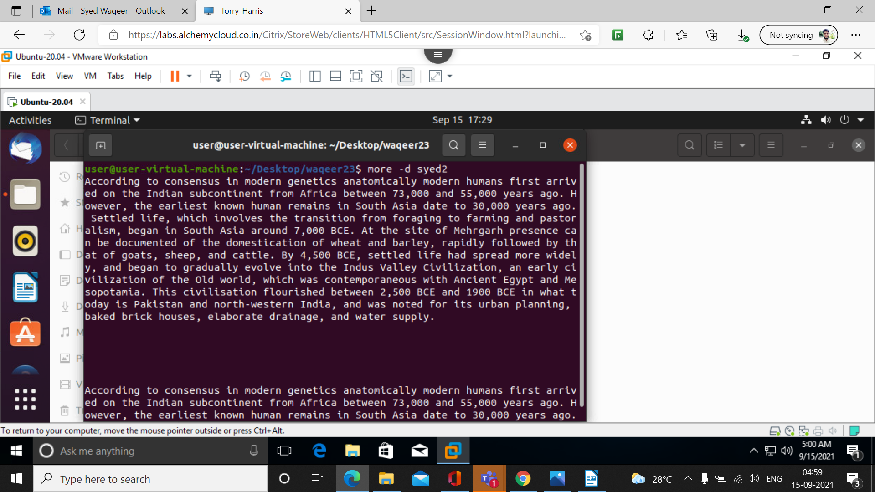
51. more -p filename

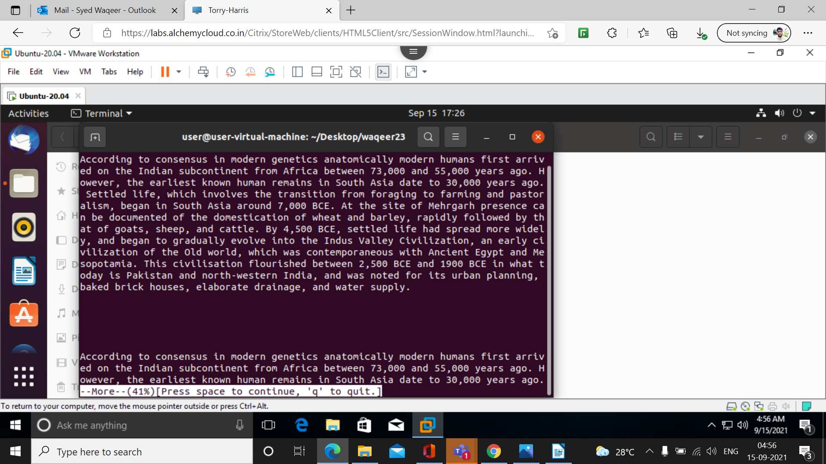

52. more -c filename

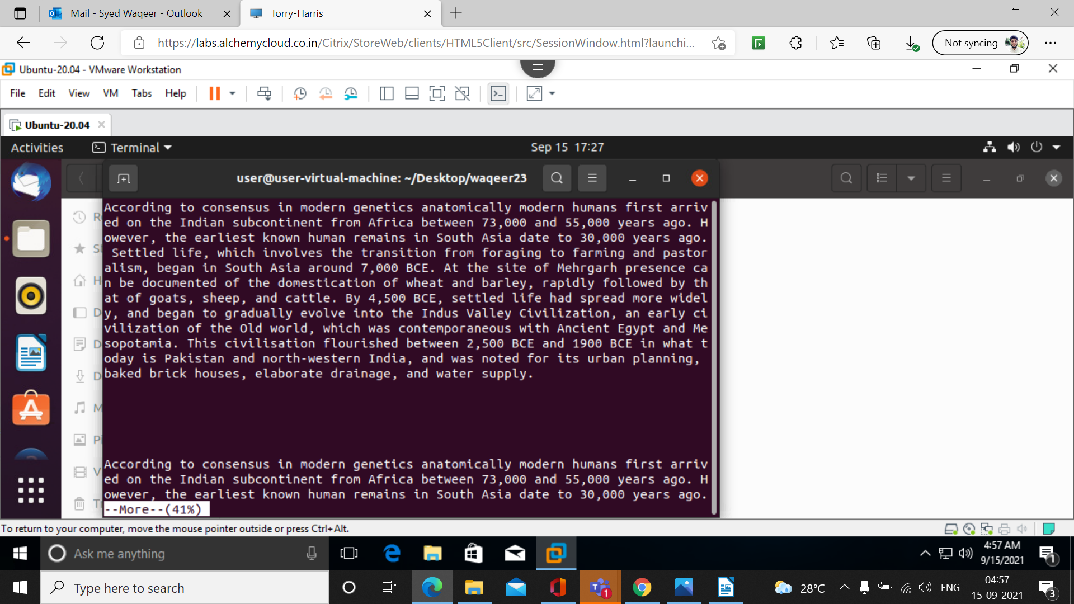
53. more -s filename



